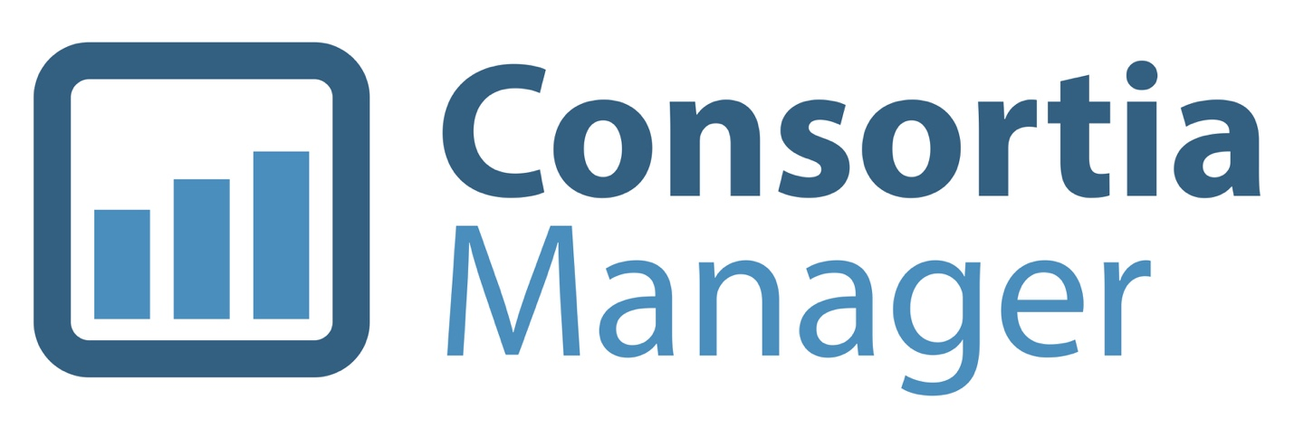

**Member Interface**

**How-To Guide**

**Table of Contents**

* Log into my account
* View my dashboard
* Managing subscriptions
  + Agreements and products

* + Subscriptions page
* View and update the member profile
  + Update library contacts
    - Add new contacts
    - Edit existing contacts
    - Users with a profile already in CM
    - Setting a password
  + Update library information
    - FTE information
    - View e-mails from the system
    - Update or remove an IP address
    - Links and attachments
* Managing renewals
  + - Shopping basket
* Using the catalog
* More options
  + Invoices
  + License agreements
  + Materials
  + Contact Form & Address Book
  + Reports
* Switch Accounts
* Interactions

**Log into my account**

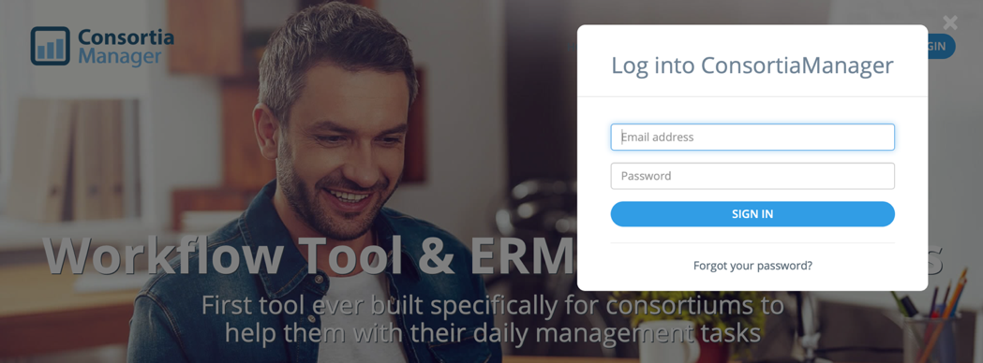Visit [www.consortiamanager.com](http://www.consortiamanager.com) and click the login button at the top right corner of the page. Login credentials are initially sent out by your participating consortium, although they can be changed once you log in. If you’ve forgotten your password, please click on the “forgot your password?” option and enter your e-mail address. A reset code will be sent to your address. Please note: It will only be sent to an e-mail address that has already been set up in the system.

**View my dashboard**

Once users are logged in, they will automatically be taken to the dashboard page.

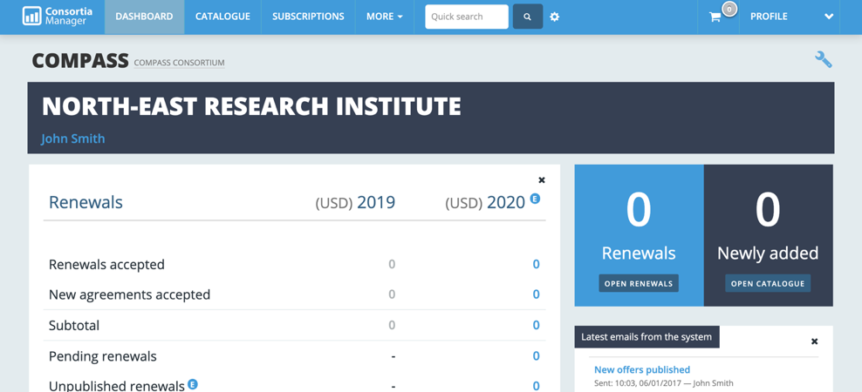The dashboard provides member libraries with a brief overview of the account and serves as the home page. There are several options of what can be displayed on the dashboard, and they can be moved around the page or removed as desired. They can also be customized by clicking on the wrench icon in the top right corner of the page.

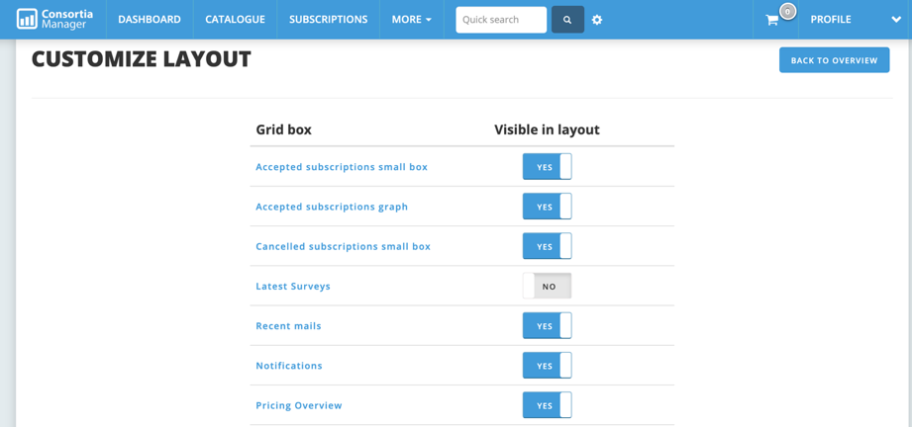

In case anything is accidentally deleted on the overview page, it can also be retrieved again by making it “visible in the layout” on this page.

**Managing Subscriptions**

From the dashboard, users can access subscriptions by clicking the tab at the top of the page.

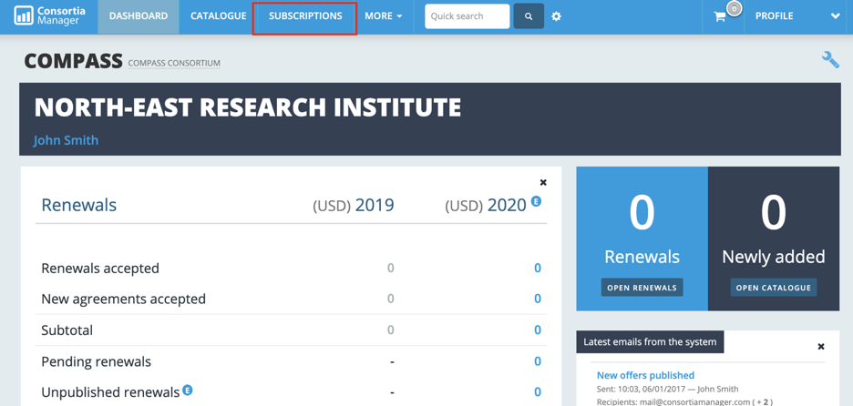

Once there, users will see a list of all subscriptions the library currently has in addition to those that were purchased in the past. These can be filtered and additional columns of information can be added as needed for easy viewing.

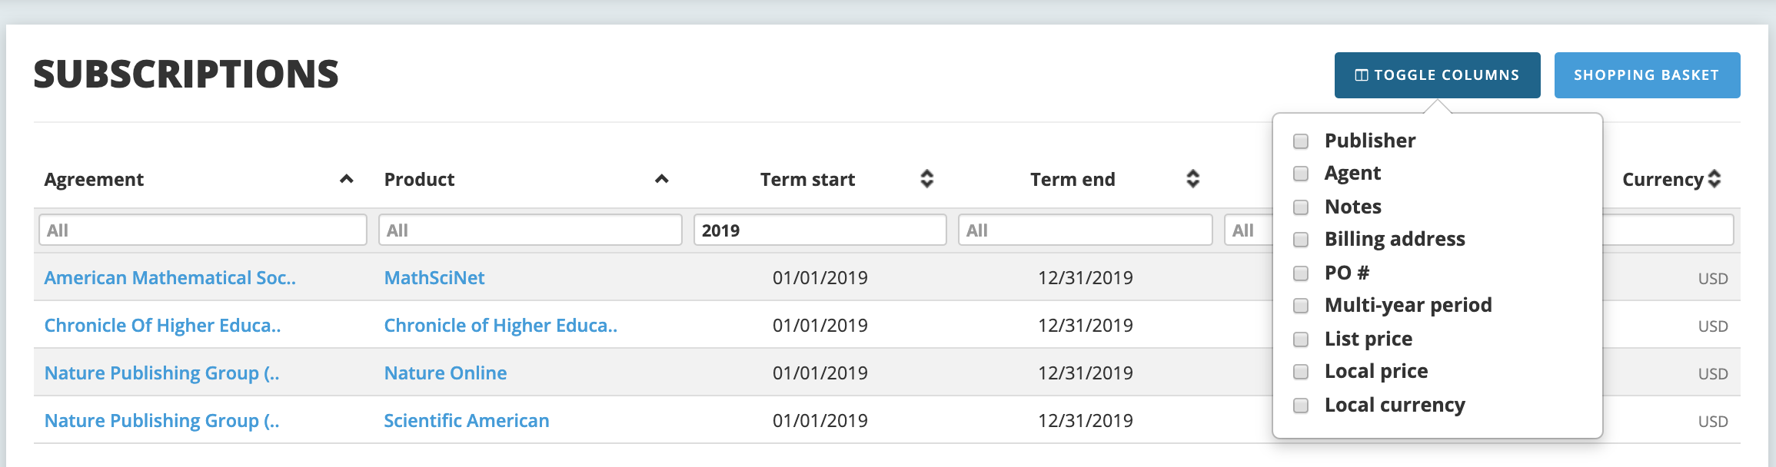

There is a distinction in CM between an agreement and a product. An agreement is the overarching title of a collection of titles while the product is a specific journal or database title. Products are linked to a parent agreement in the same way they are linked to a publisher.

From here, users can click on the agreement link for more information. It can also be searched in the search bar or clicked on via the catalog.

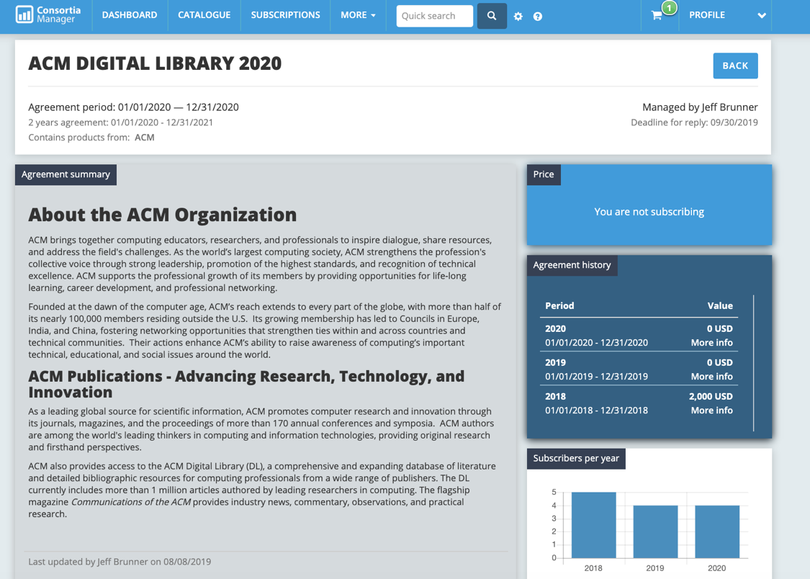The agreement page will have a bevy of information about any current and historical subscription pricing, information about the publisher or journal collection as it pertains to that agreement as well as information about the number of subscribers within the consortium and more detailed pricing information.

The products that are related to this agreement are listed out next to the publisher’s contact information. They can be clicked on for more information about that product specifically.

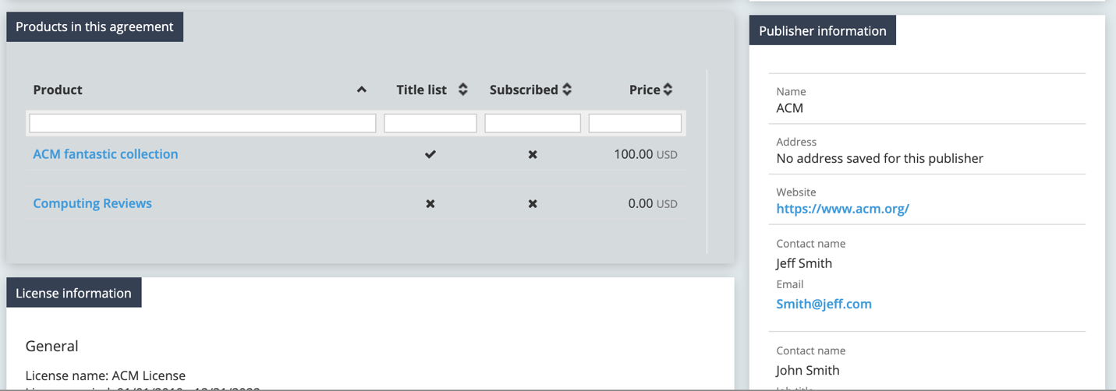

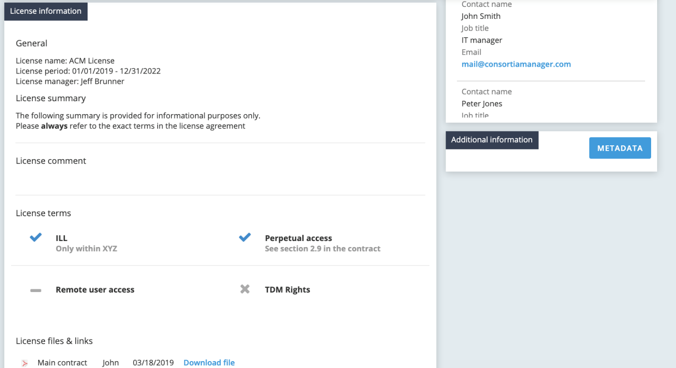

Further down the page will share other subscribing libraries to that agreement within the consortium and any relevant links the consortium has shared.

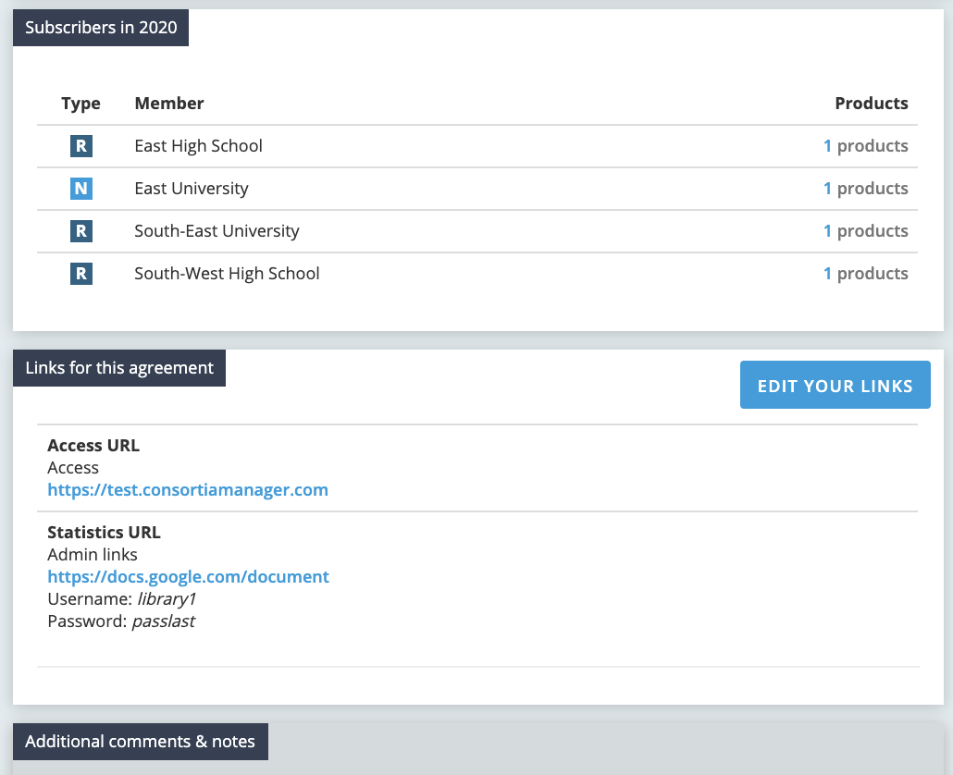

Lastly, the bottom of the page provides room to include any extra notes, attachments, and to view the latest activity on the agreement. Notes and attachments can be added by both the library and the consortium.

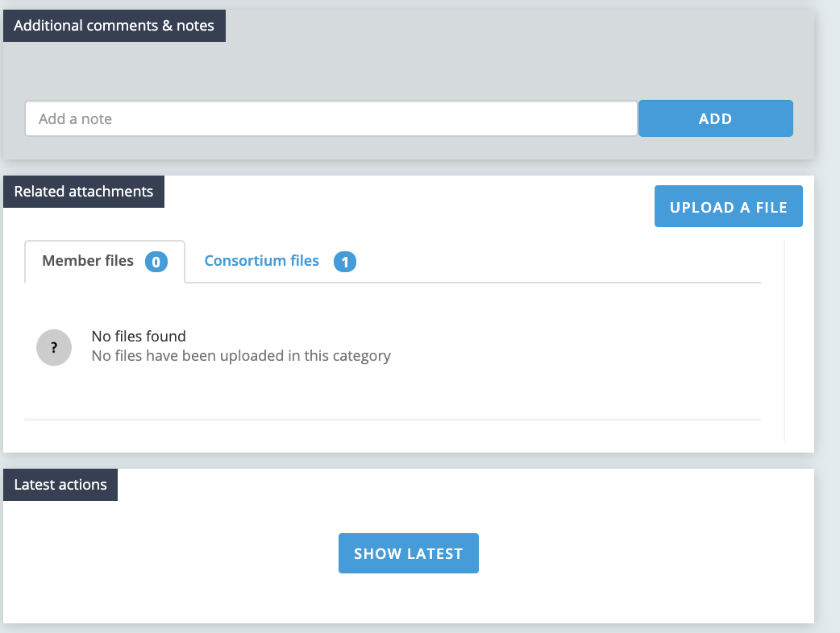

**Subscription Page**

The subscription page looks fairly similar to the agreements page:

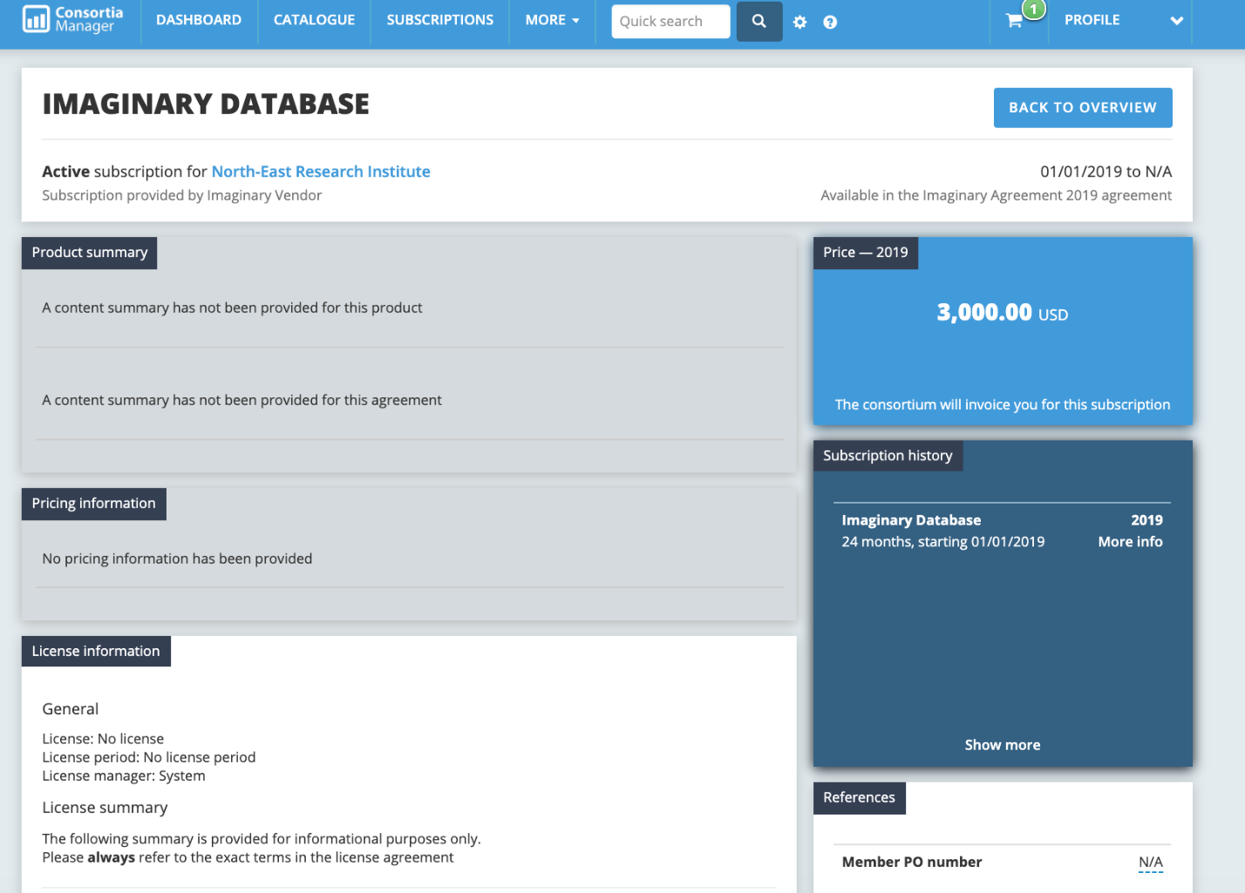

Since a library subscribes to a product within the agreement, more information here is specific to the library’s active subscription and relates to where it stands in the member workflow, such as the milestones timeline.

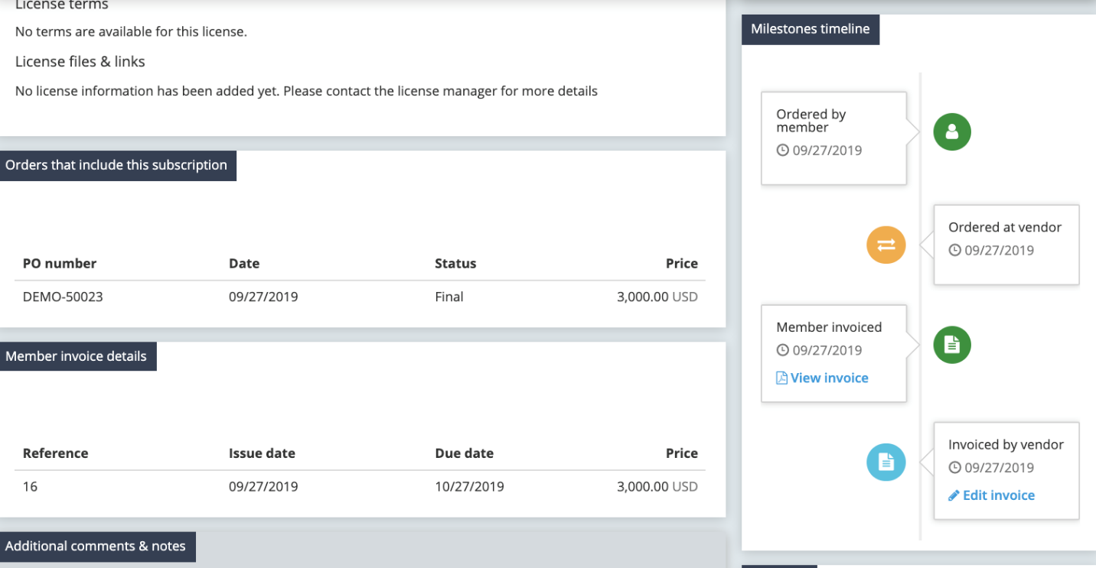

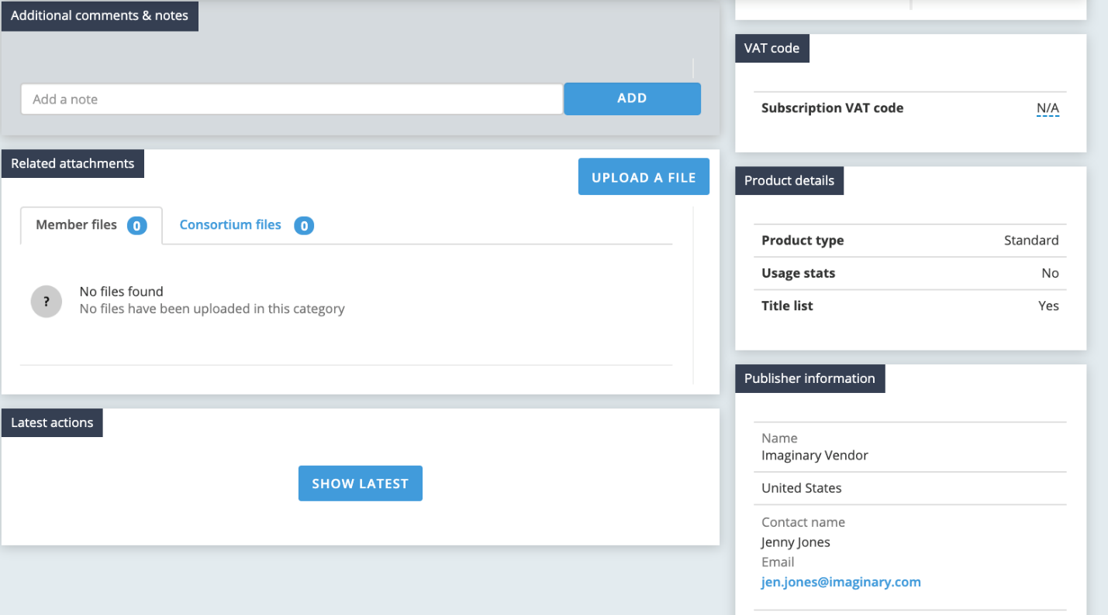

**Member Profile**

From the dashboard page, click on the “profile” button to view a drop-down option to “view profile.”

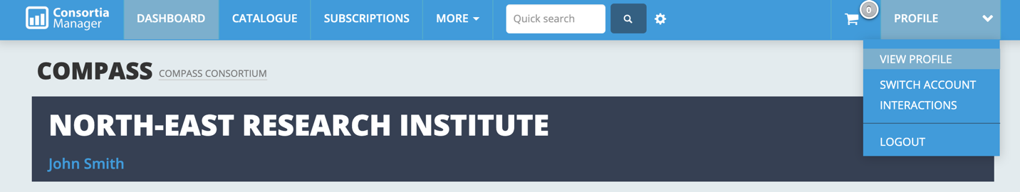

Once there, most information about the library that will appear in the boxes below can be edited by clicking on the “edit library” option:

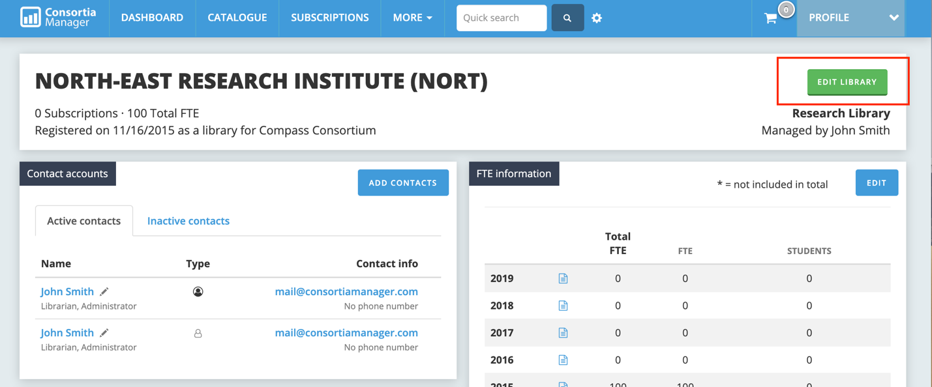

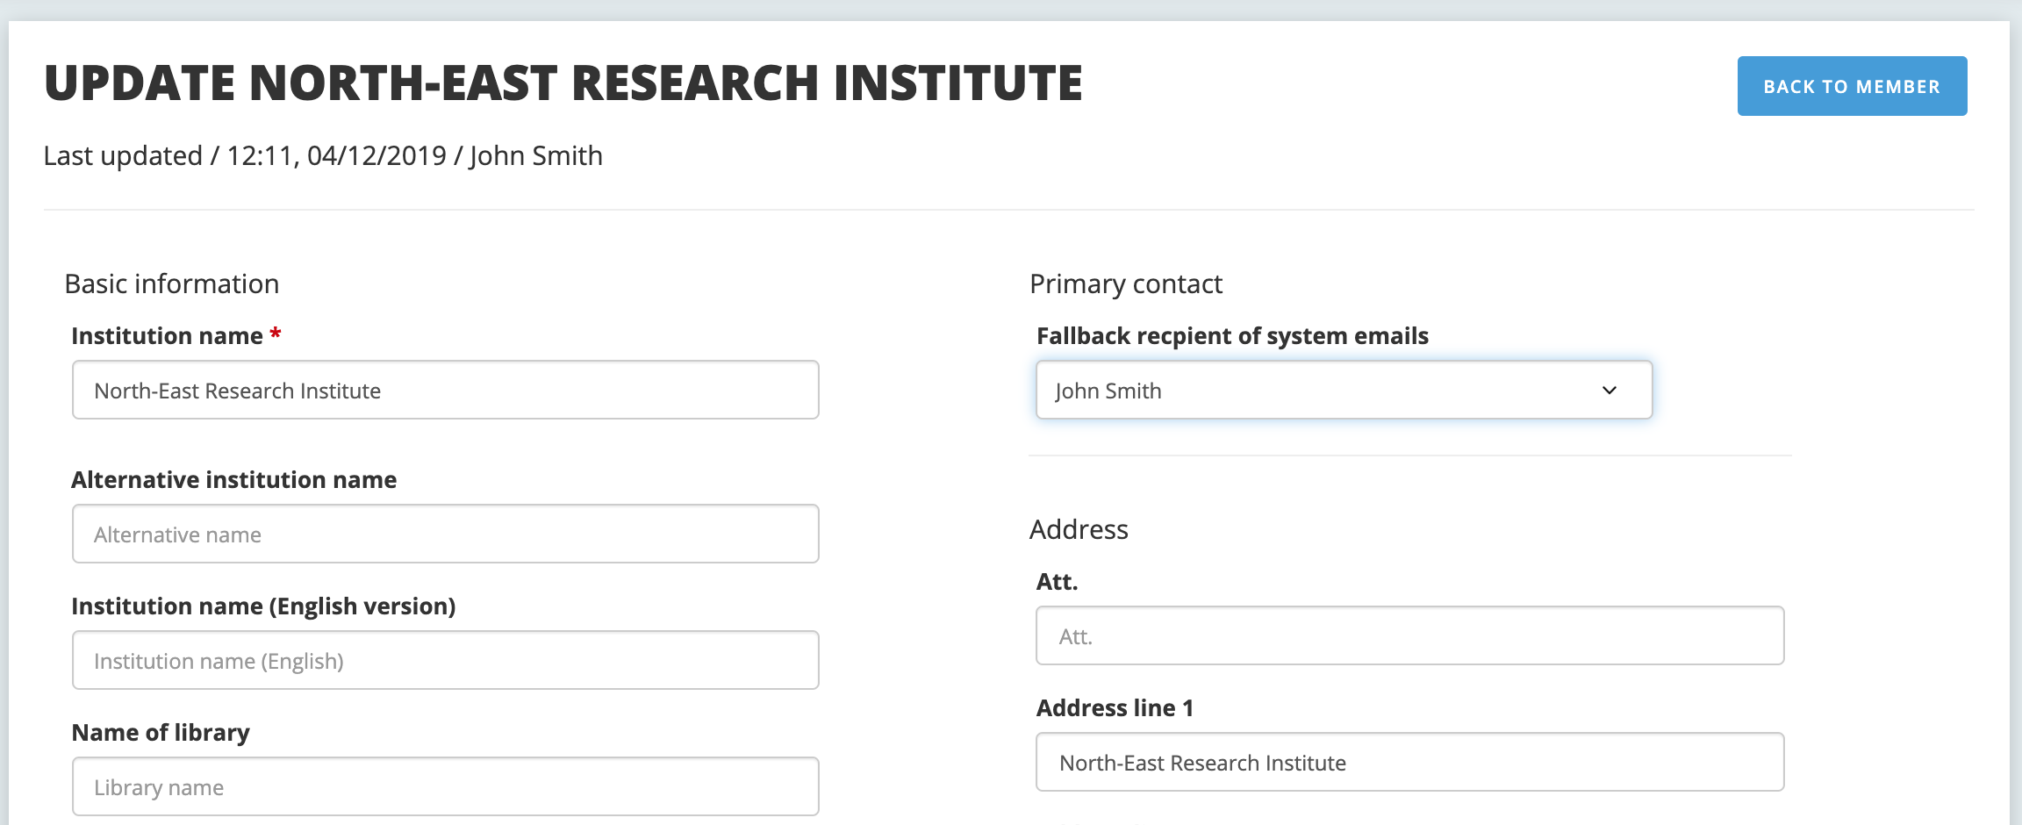

Users can update basic information here (address, primary contact, phone number). There are also some more specific details libraries can include:

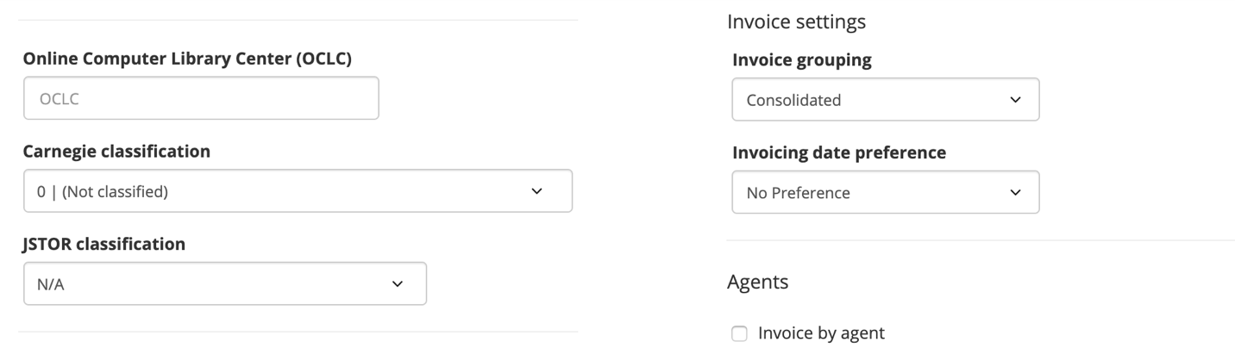

Your library may not use all of the options listed here, but it just goes to show there are many ways to share information as it applies to your library and your library’s relationship with your consortium.

**Update library contacts**

Once you click on “view profile,” the option to view the library’s contact list will appear below. New users can be added by the “add contacts” button, and current users can be edited or removed by clicking on the edit pencil next to the user’s name.

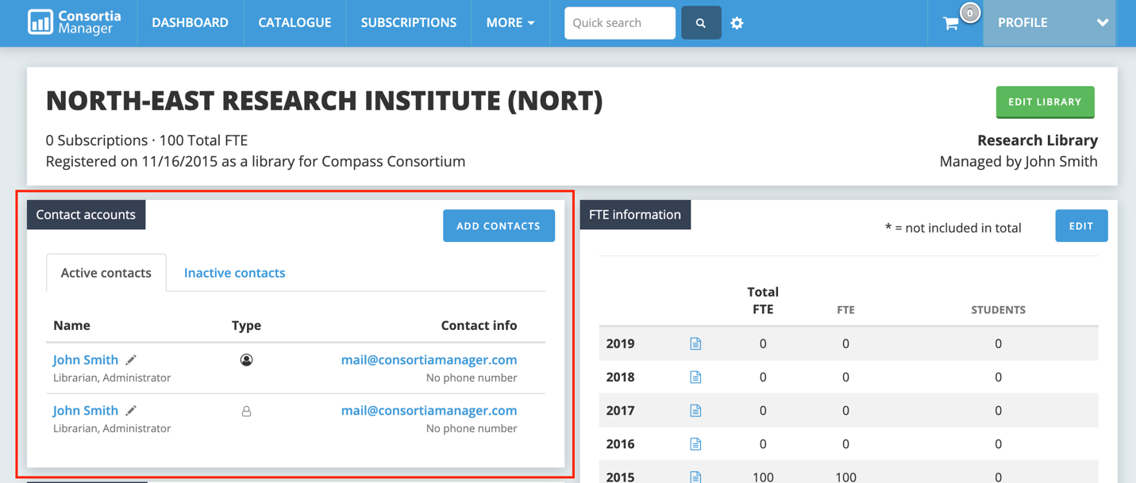

**New contact addition**

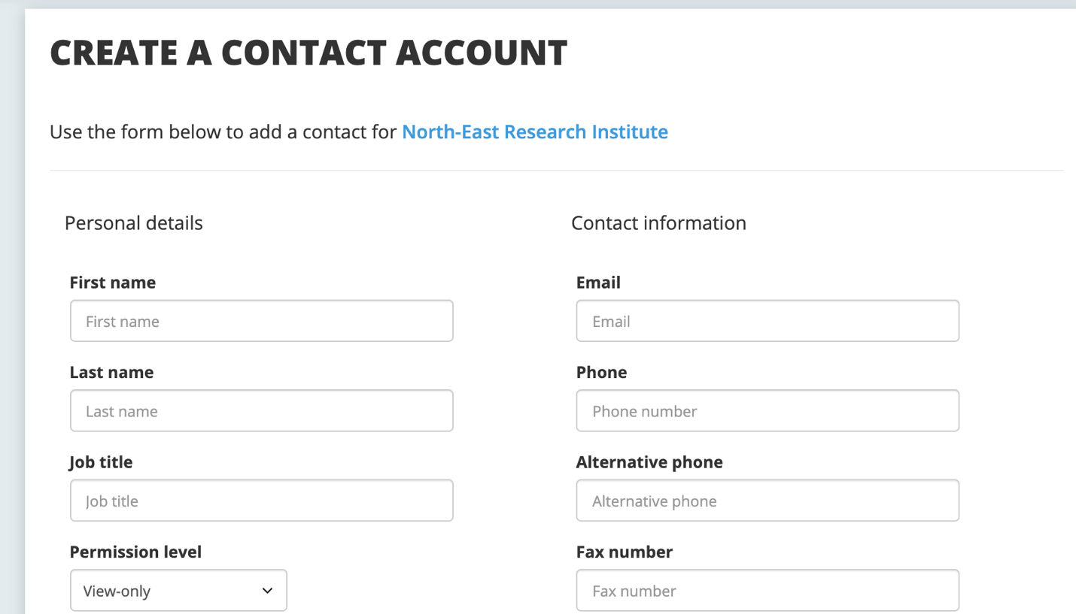

When a new contact is created, there are two fields that should be paid attention to: the permission level and the e-mail options. Passwords can also be reset here.

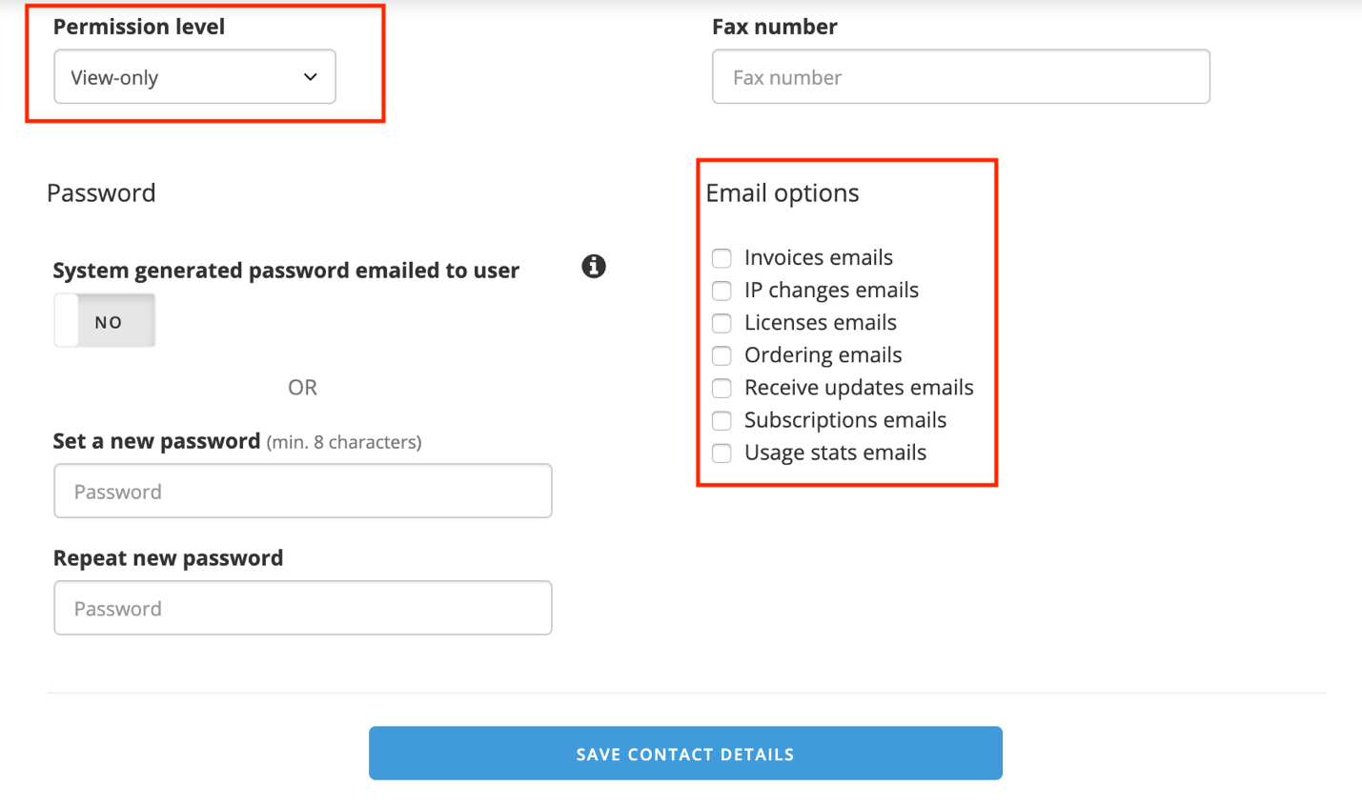

The permission level has three options: View-only, user, and administrator.

* Administrator allows the user to modify all information about the library, add/remove contacts, renew/cancel resources in the system, process invoices, and participate in all functionality of the account.
* Users can renew and cancel subscriptions and can view information.
* View-only works just how it sounds; no changes can be made.

The e-mail options will determine which contacts receive information about different functions in the system. The description list included below is also listed on the new contact page.

**Invoices emails**

All invoices if sent via email and other related invoice matters

**IP changes emails**

Emails related to IP changes

**Licenses emails**

Emails related to licensing for instance notifications about changed licenses

**Ordering emails**

Emails re. new offers, renewals, reminders for renewals and order confirmations

**Receive updates emails**

Updates from ConsortiaManager on new features, tips and tricks, and general information re. the system

**Subscriptions emails**

General information from the consortia for instance emails re. subscriptions that are about to start, general inquiries etc.

**Usage stats emails**

Emails related to usage stats

**Editing or removing an existing contact**

This page will look very similar to the “add a new contact” option.

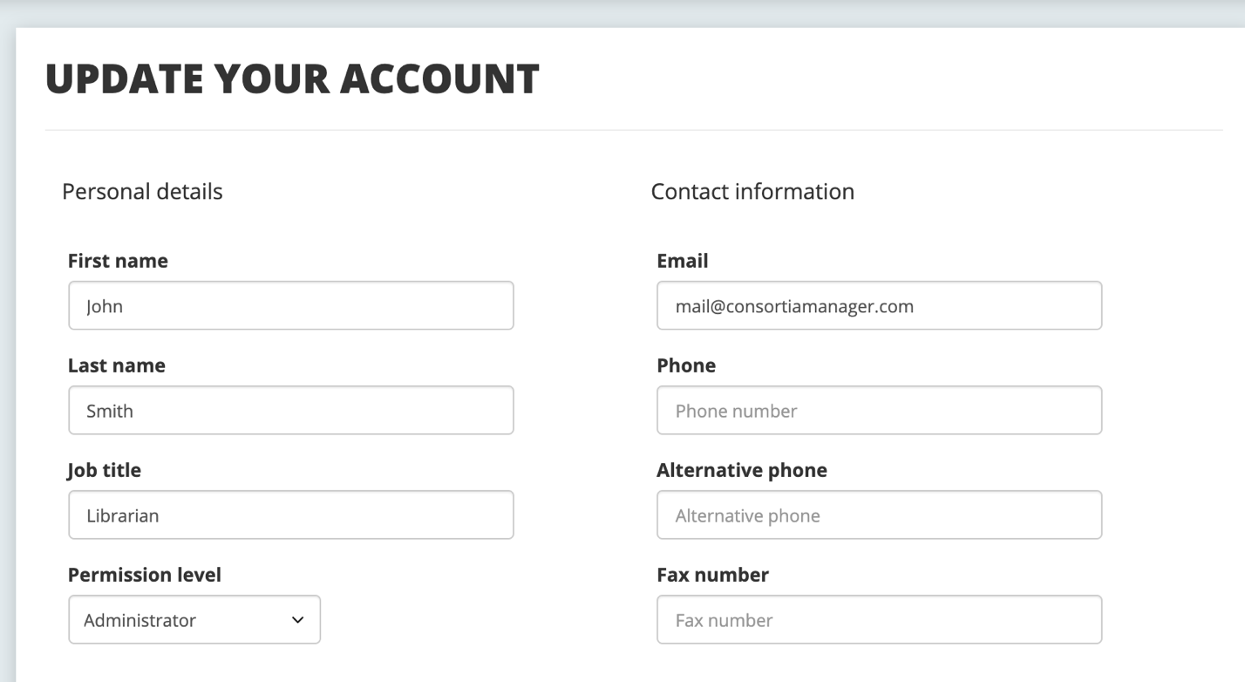

If the user has been set as the primary account, they cannot be deleted. If they are not the primary account, there will be an option to deactivate on this same page:

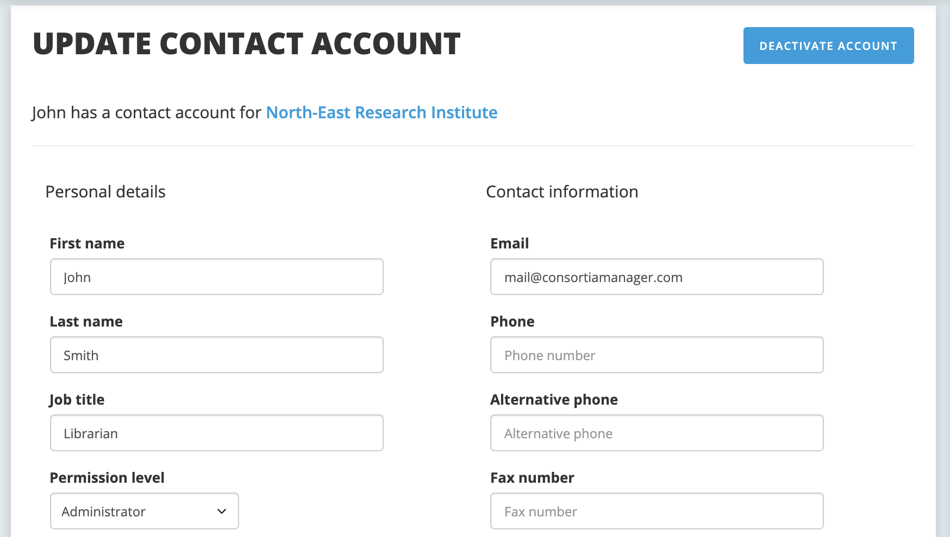

On the profile page, the primary account user is noted by a bolded user icon:

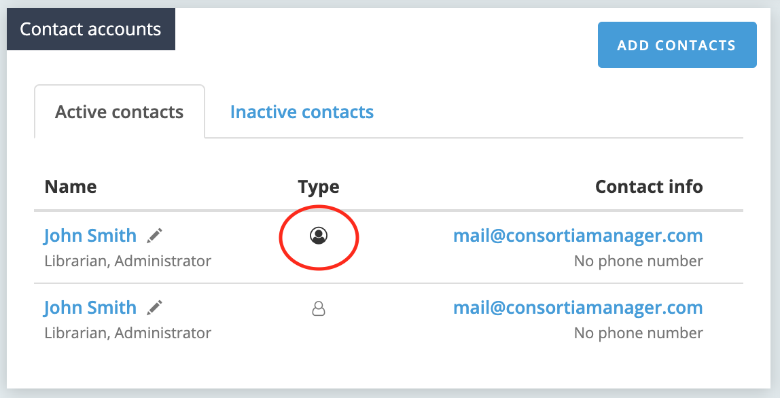

Once a user has been deactivated, they will appear in the inactive contacts tab, as seen above.

**Users with a profile already in CM**

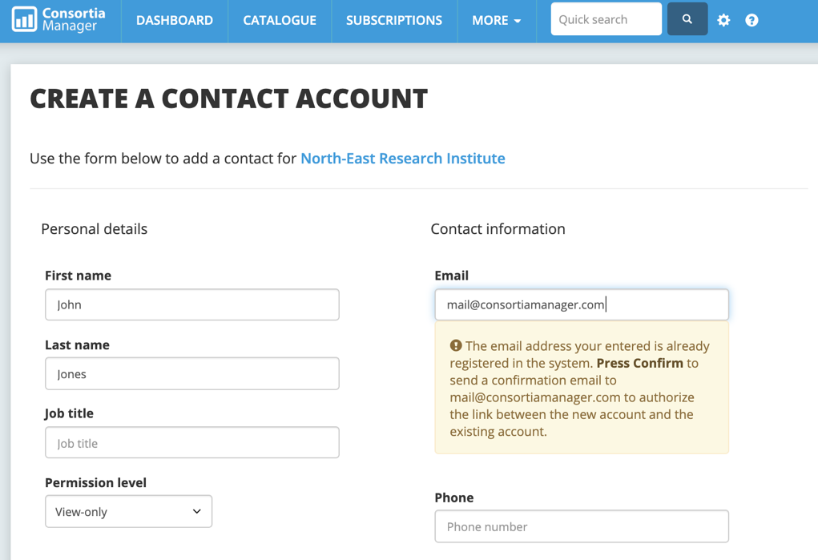If a user already has an account set up for them in the system and there is an attempt to add them to the contacts list, a message will appear to help appropriately link the accounts with the corresponding library or consortium. It is possible for a user to have an account affiliated with more than one institution (i.e. located at two different academic branches that have separate resource budgets).

**Passwords**

In order to generate a password, users can click on the edit pencil next to the desired contact and scroll down to view two options.

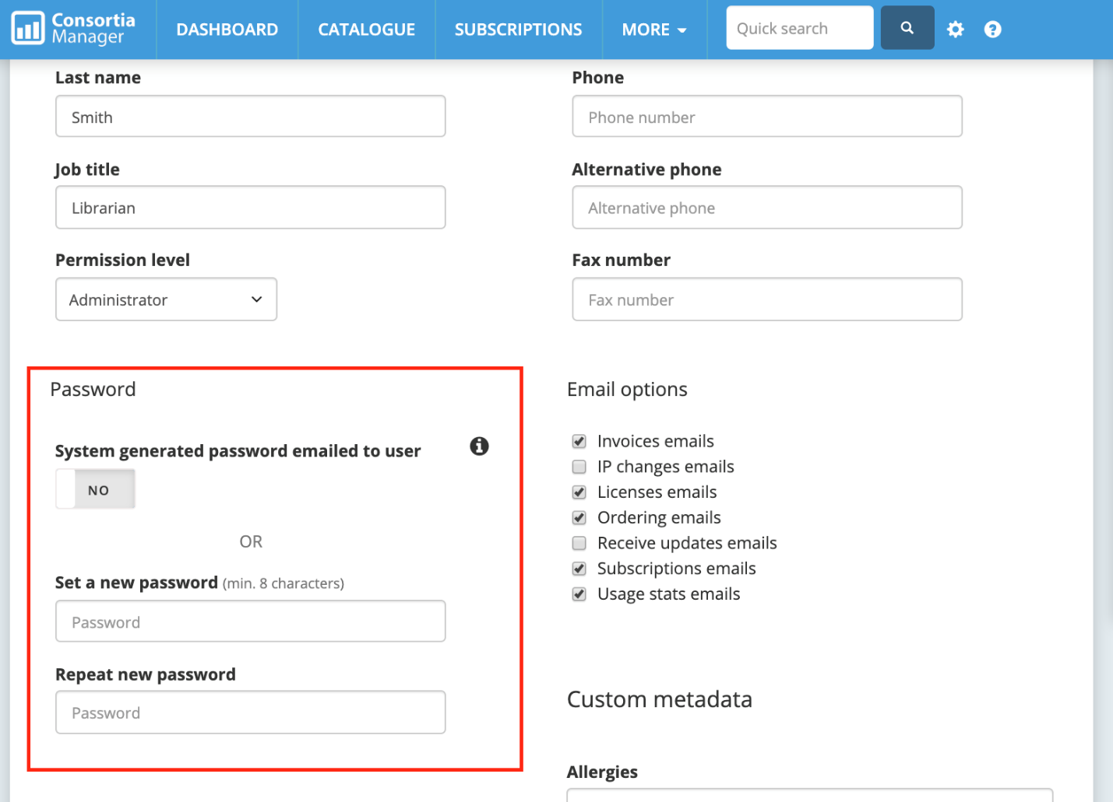

The system can generate a password that will be e-mailed to the user or the user can choose their own new password before clicking “save contact details” at the bottom of the page.

**Updating library information from the profile page**

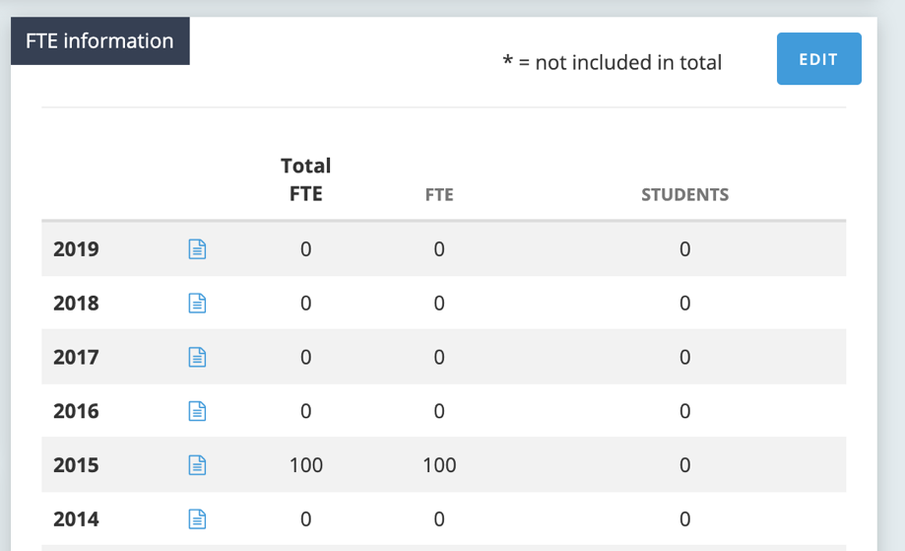

There are several things than can be shared about the library with the consortium from the profile page. Besides contacts, users can update their FTE (or population served for public libraries, or whatever the preferred measurement is).

Since this information is often used to obtain pricing with vendors (even for renewals), please ensure these numbers are up to date. Should you need to add any notes, the notes icon can be clicked to include more information (i.e. an increase in funding due to a new degree offering, etc.).

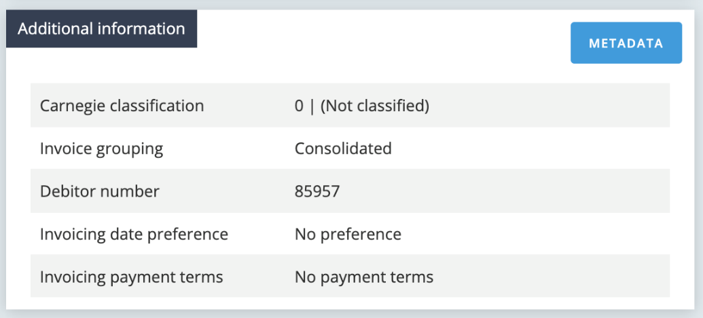

There’s a box with “additional information” below the FTE information on the profile page:

All of this information comes from the main profile, so if it needs to be changed, please edit the main library profile.

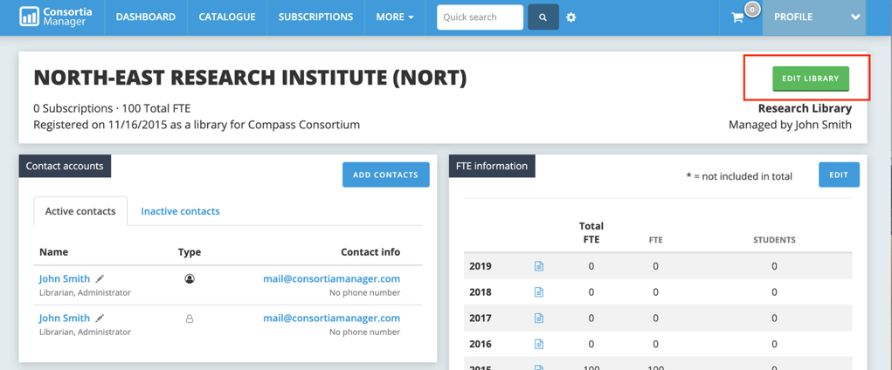

Further down the profile page, users can also see a list of recent e-mails sent to them by the consortium.

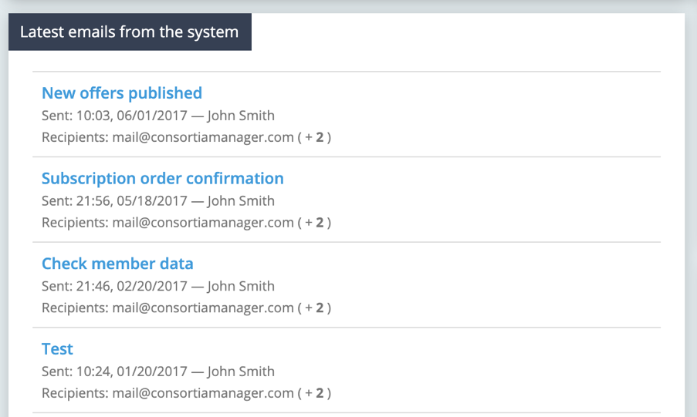

Libraries can also view and update their IP addresses. Similar to inactive library contacts, inactive IP addresses are stored in a separate tab.

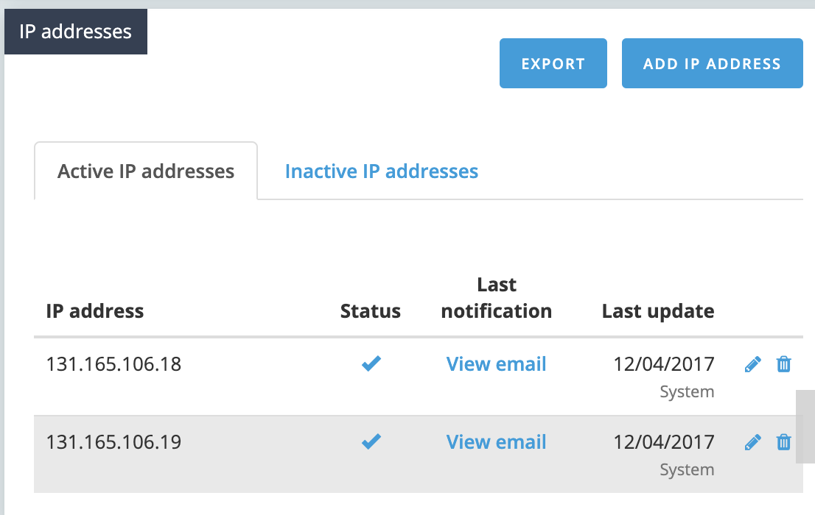

When adding or updating an IP address, users will click on the “add IP address” button to view the following screen:

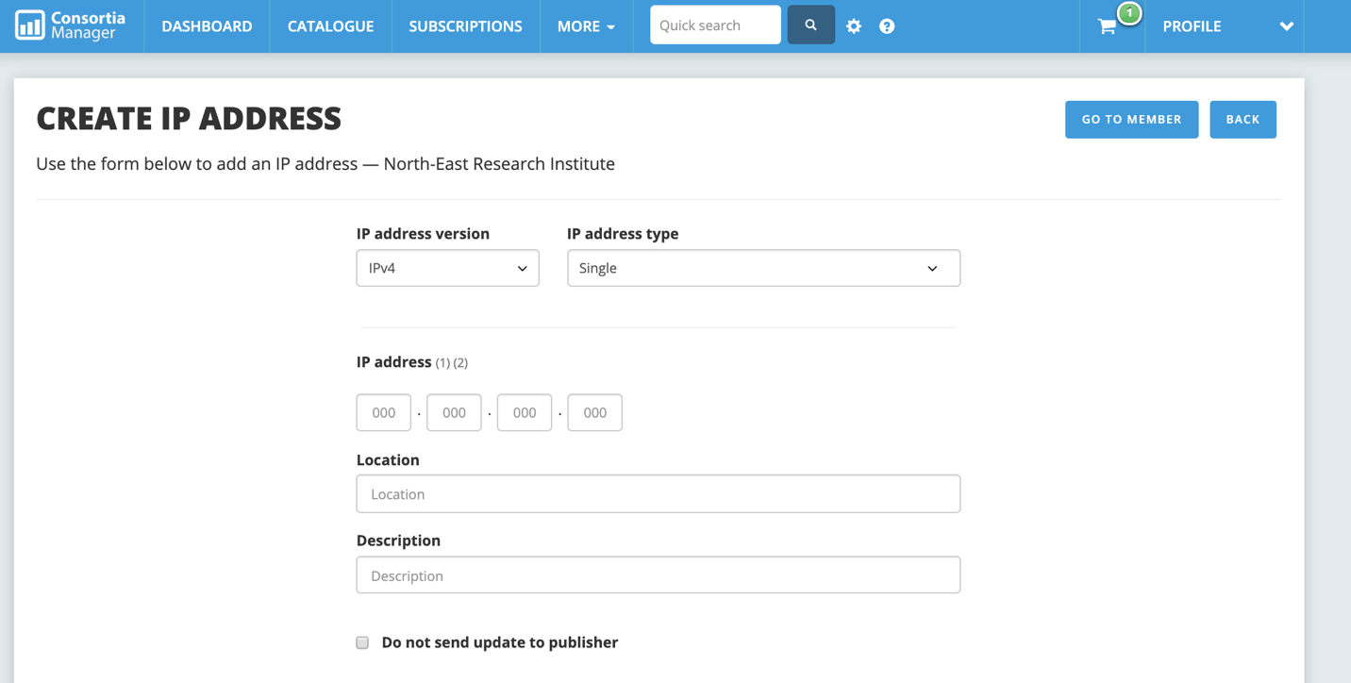

There is an option to add either IPv4 or IPv6 as well as selecting the type of single or range. When entering the IP address, please type out the full address instead of abbreviating with an asterisk. Whenever those addresses are updated, vendors for all current subscriptions will automatically be e-mailed with the new information in order to ensure continued access. Users can opt to not contact the publisher by clicking the box at the bottom of the page.

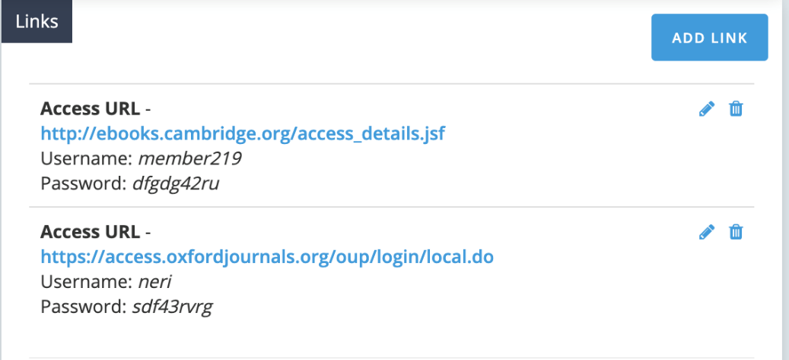

Links and attachments can also be included on the member profile (i.e. the consortium-library member agreement).

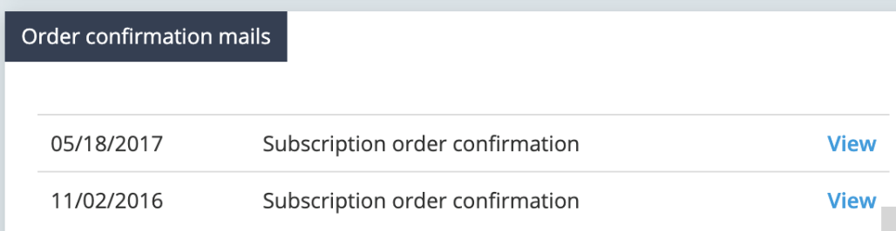

Lastly, a list of order confirmation messages rounds out the page.

**Renewals**

Any open renewals that need to be accepted or rejected will be listed in the dashboard overview, as well as the blue “open renewals” box pictured above. If you click on “open renewals,” users can see a full list of subscription awaiting decisions. The pending renewals will appear.

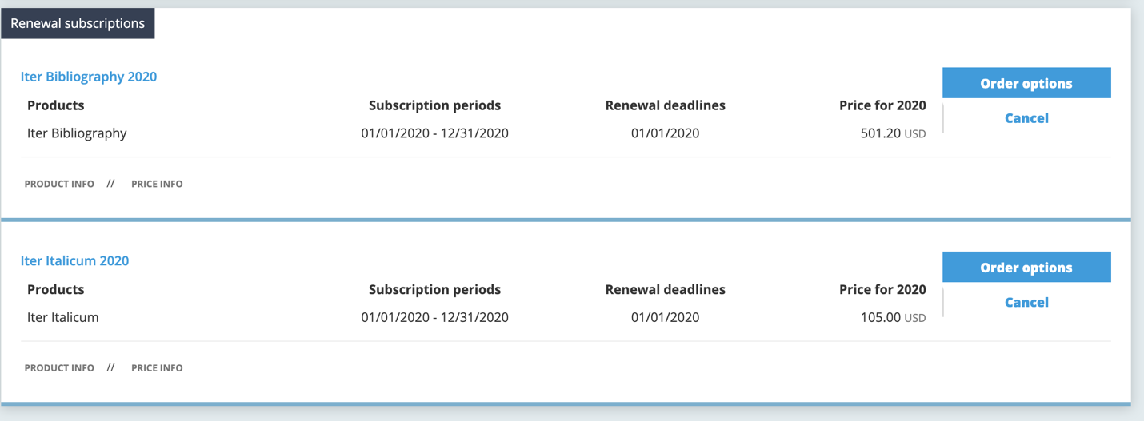

The library can choose to cancel these subscriptions for the upcoming subscription period or they can click “order options” to accept, which will also provide options to include and view additional information.

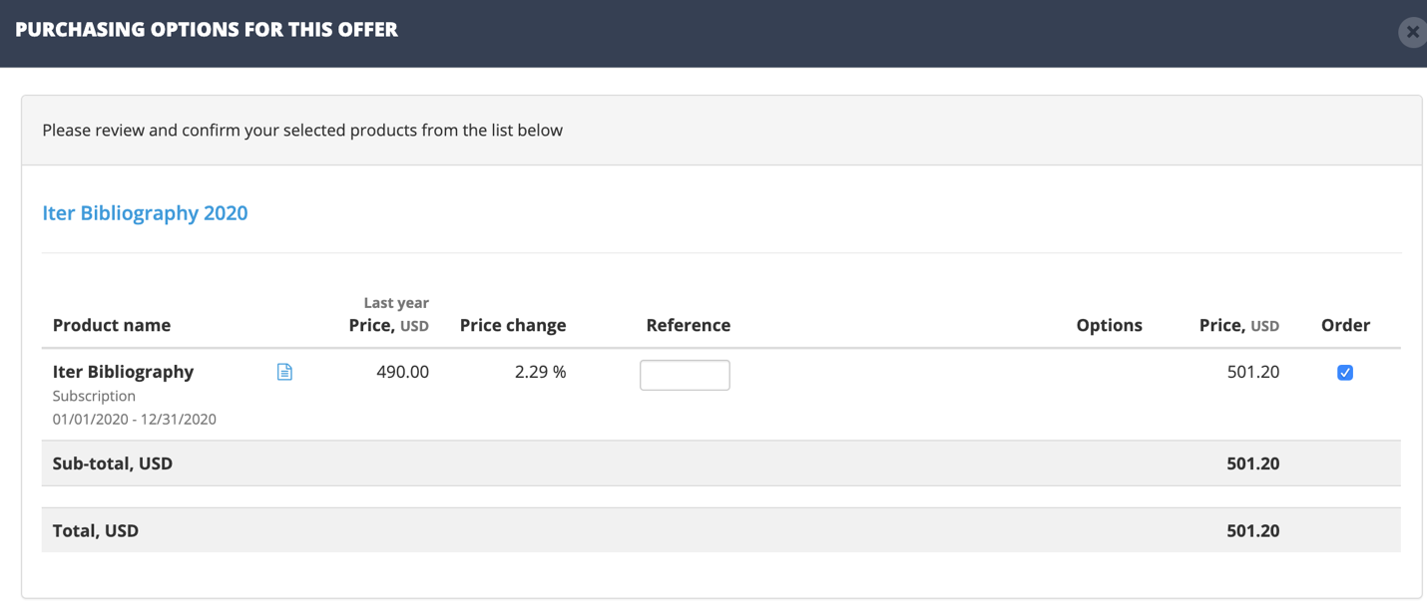

Once items are accepted, they can then be added to the shopping basket. Items can be added individually or all at once. They are not officially ordered until after the order has been placed from the shopping cart. Products that are not current subscriptions but are new orders can also be added from the catalog, as long as pricing is available.

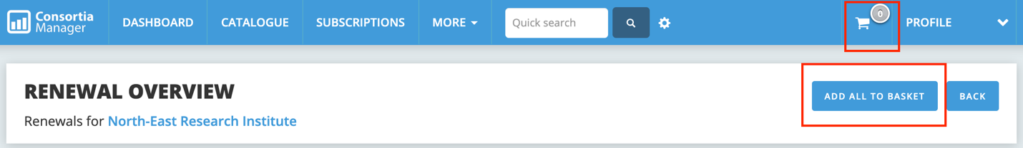

In more detail, a library would see a list of subscriptions available for renewal. If all subscriptions in the list are ready to be placed in the shopping cart where the final order will take place, click “add all to basket.” This is also true for multi-year subscriptions that require year to year confirmations, as evidenced below.

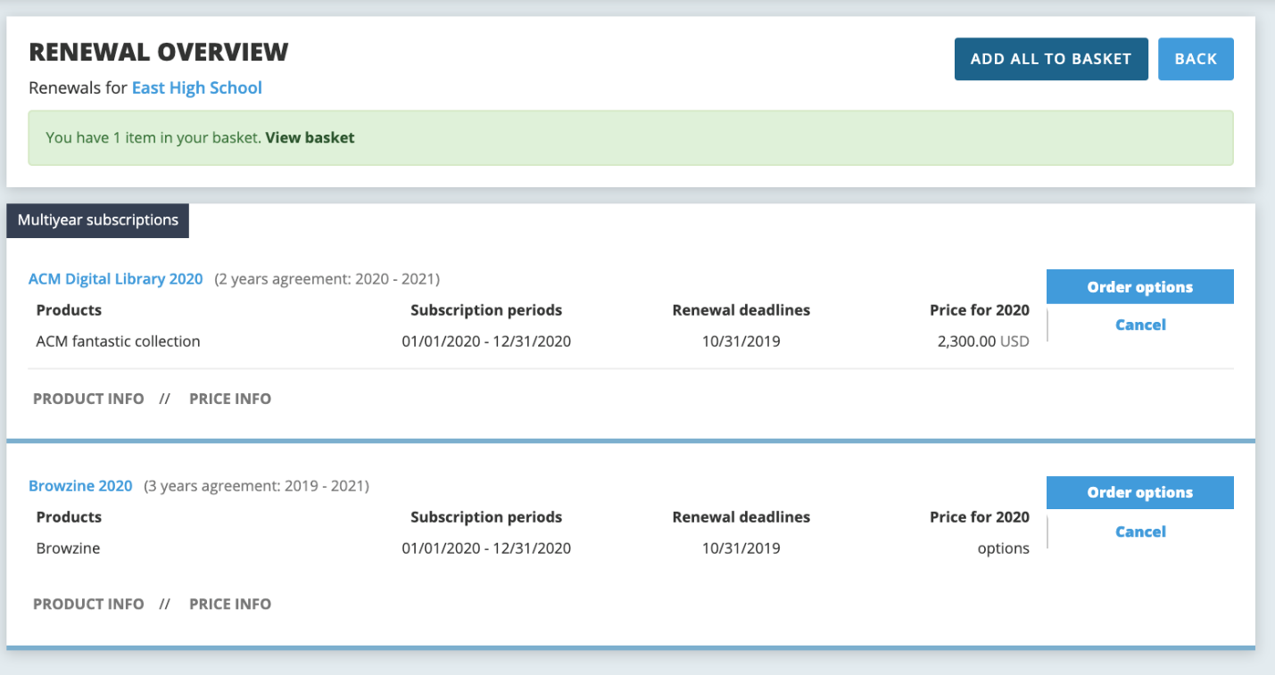

**Shopping Basket**

Once items are added to the shopping basket, users can view all information before choosing to place an order of any desired items. Be sure to use the check boxes to mark the renewals you wish to include when either placing the order or printing. The trash can icon next to the check box allows users to remove subscriptions from the shopping cart. This action will not cancel a subscription, it will just place a renewal back in the renewals list or a new product back in the catalog. All products will be categorized under their parent agreement (i.e. two separate journal renewals could be under the heading “EBSCO Journals”). Additionally, the “R” icon in the shopping cart (and elsewhere in the workflow) stands for “renewal” while “N” indicates a new order.

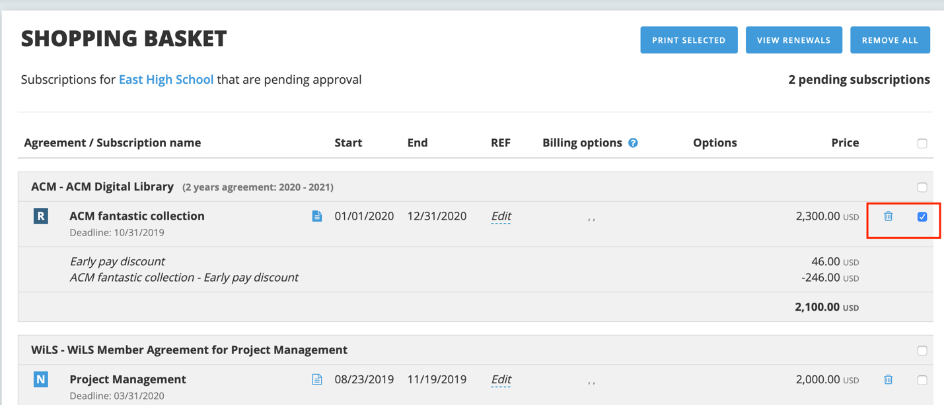

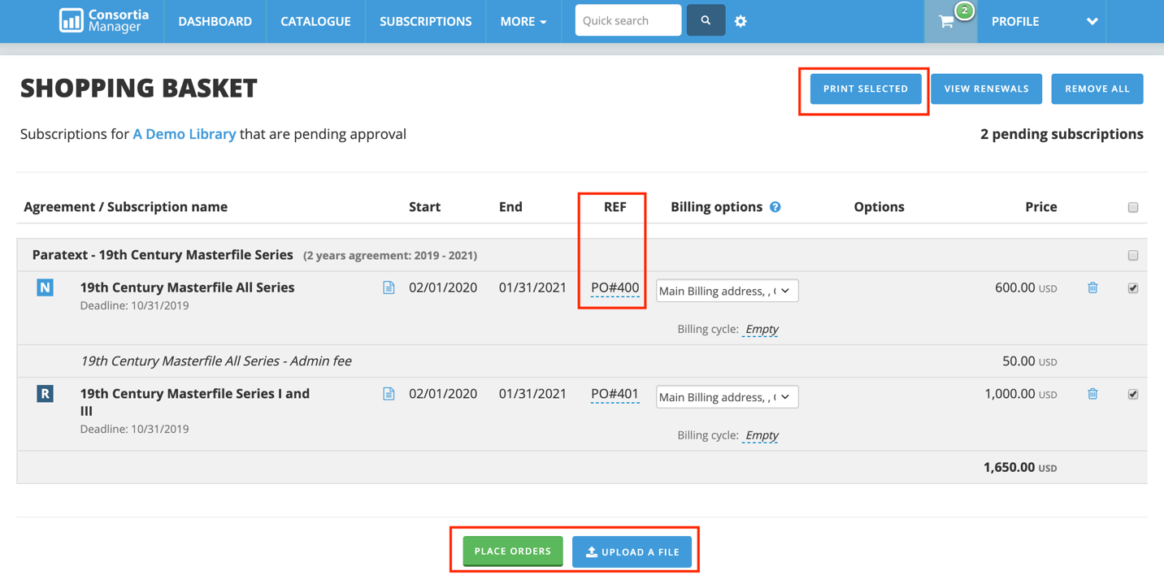Please note the “REF” section, where users can opt to type in a purchase order number or a department to be referenced. It can also be left blank. Files can also be uploaded and submitted to the consortium as part of the order. Depending on the consortium, libraries might be able to choose another billing address from this page before submitting to the consortium for invoicing. The billing address can be added or edited from the library’s profile page.

Lastly, this page can also be printed as a PDF and used as a pro forma invoice.

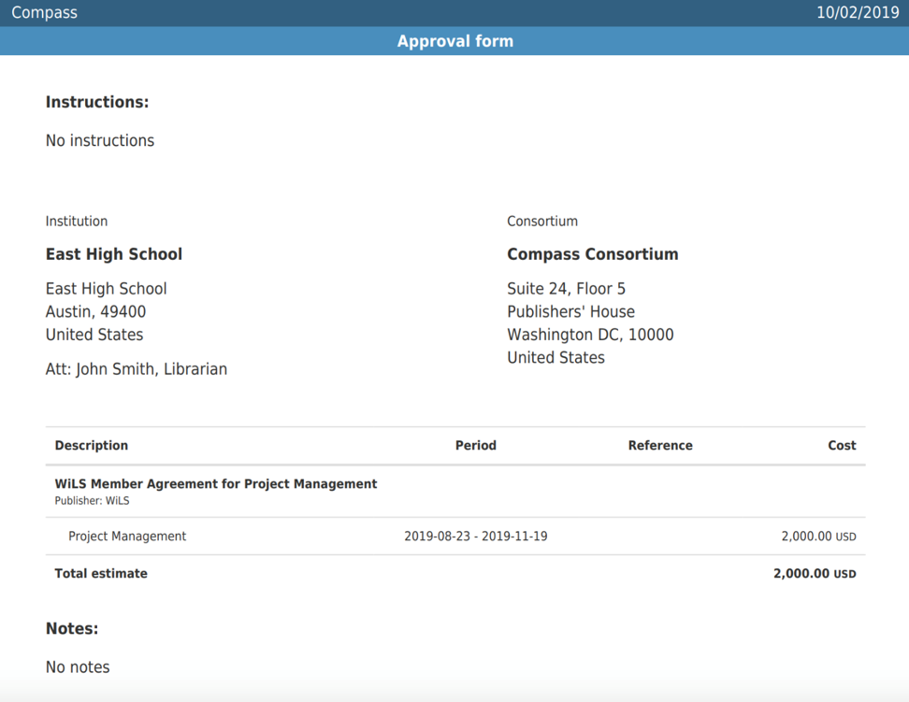

**Using the Catalog**

Users can access the catalog from the dashboard. The catalog is a full listing of all resources available for purchase from the consortium for your library. The “newly added” box on the right-hand side will alert users to all recent new additions to the catalog that the library may be interested in considering for subscription.

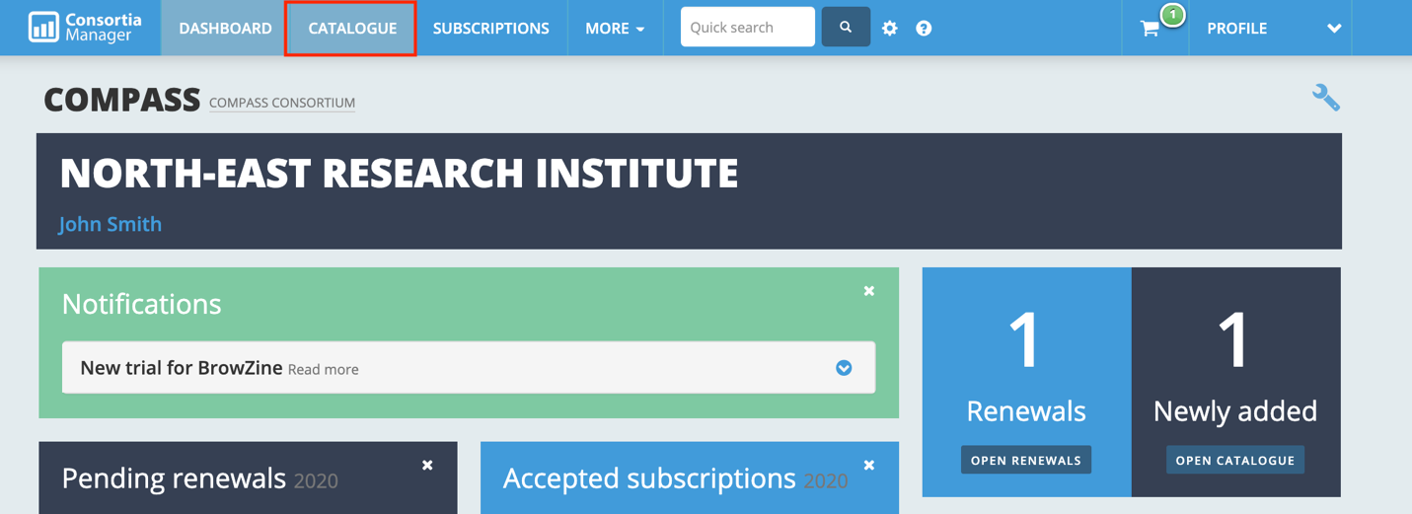

Since the catalog is such a large list of products, it’s highly likely that only some resources will have pricing available. However, they can be requested by clicking on “request price.” Resources that do have pricing can be immediately added to the shopping cart for future ordering.

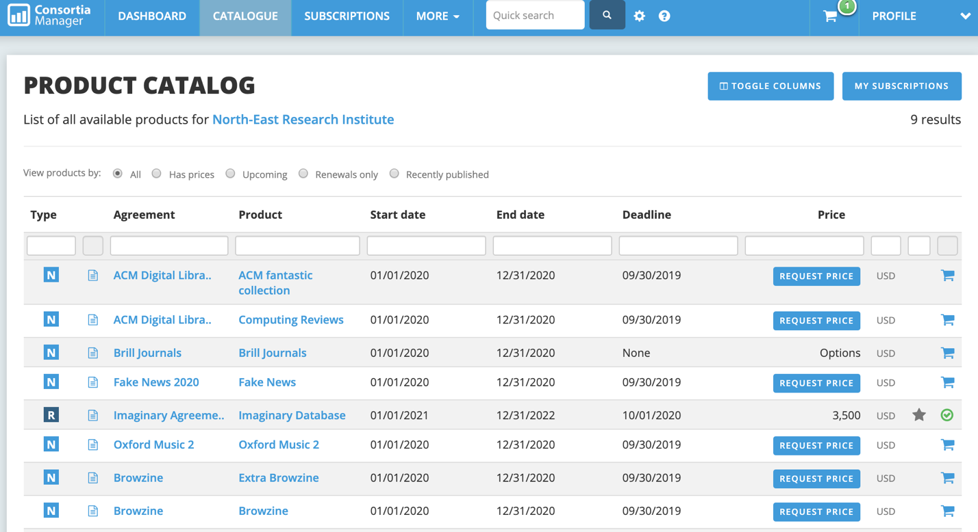

Users can also better filter what resources they want to see by clicking on the “toggle columns” button, similar to the subscriptions page.

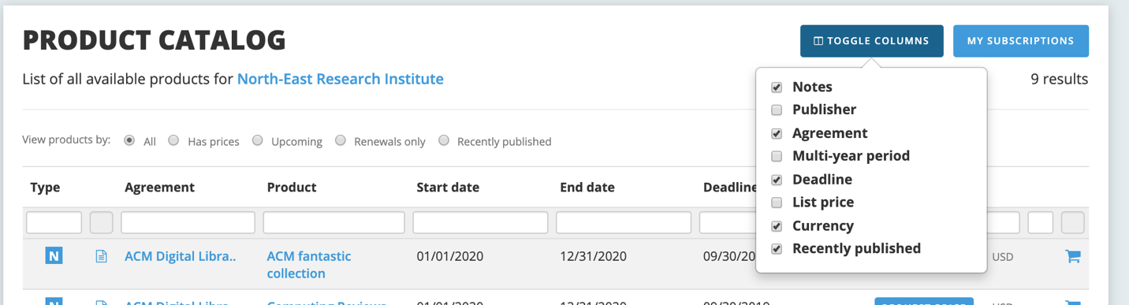

This is another location to view the library’s current subscriptions as well. In addition to filtering via the columns, there are several options next to “view products by” that will allow users to find items that either have available pricing, have upcoming deadlines, are current renewals, or were recently added to the catalog by the consortium. For example, the upcoming deadlines filter would show the following results if the search were conducted on 10/3/2019:

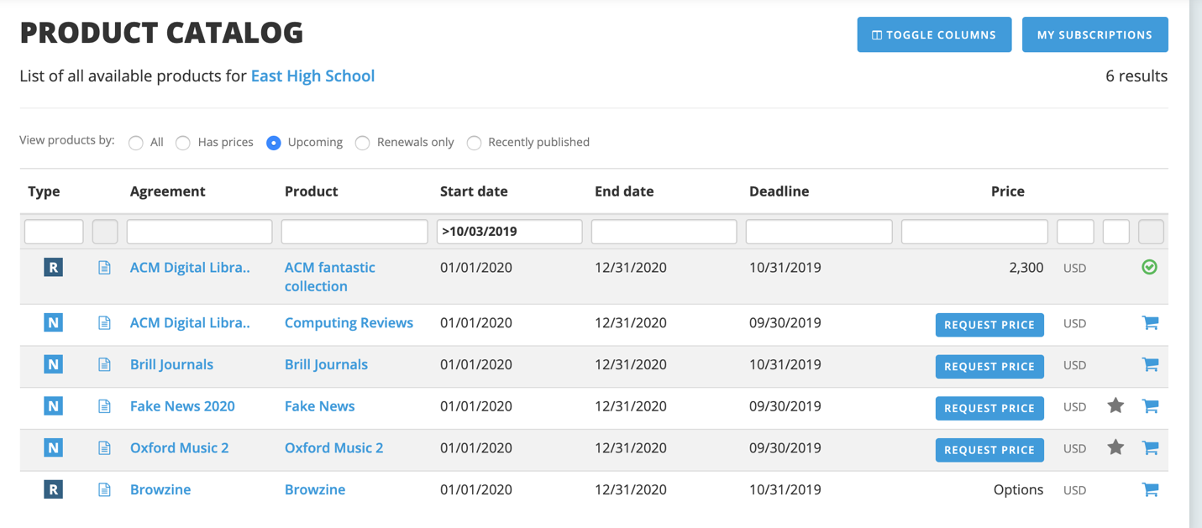

**More Options**

The last tab in the dashboard has several options, which may vary depending on your consortium.

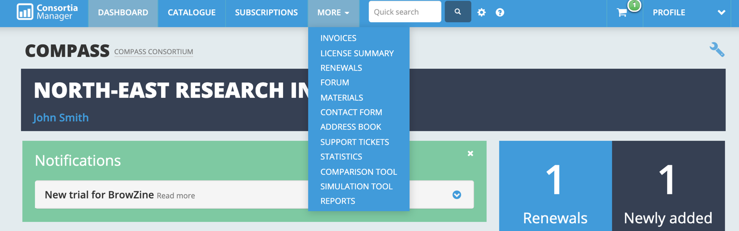

**Invoices**

Member invoices will provide the library with a full list of all invoices issued to them by the consortium.

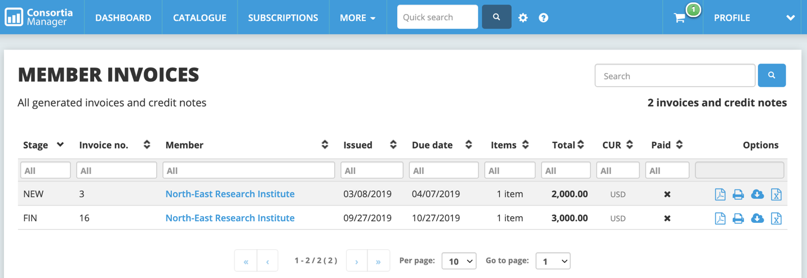

Libraries can download, save, and print these invoices. The paid column will track whether the consortium has noted they have received the library’s payment for that invoice. Any invoice credits will also appear in this section.

**License Agreements**

The license agreement page will give libraries a better understanding of some specific terms of their subscriptions, as defined by the consortium. How much information resides on this page is fully dependent on how much the consortium dedicates to parsing out the agreement terms.

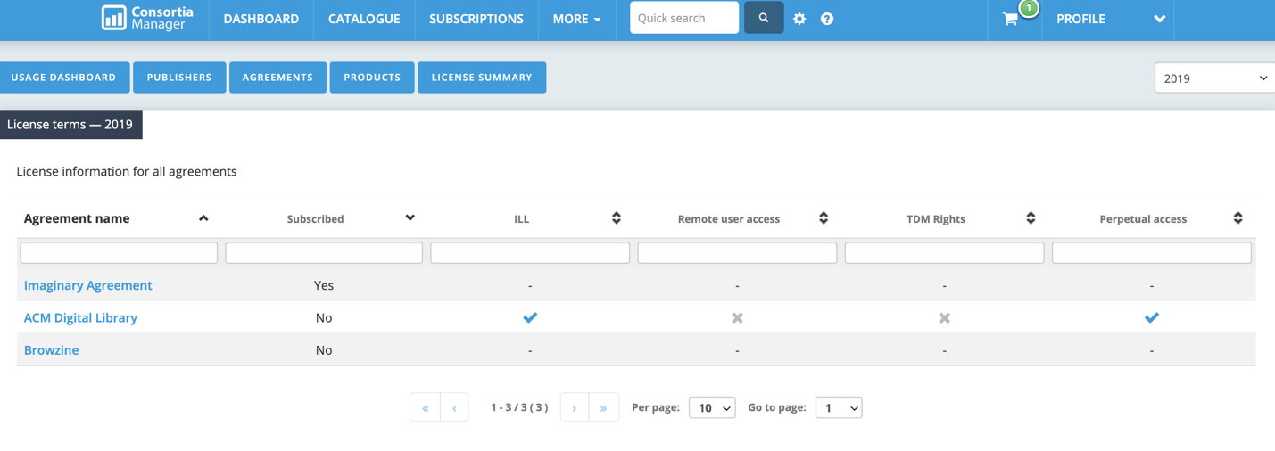

**Materials**

The materials tab serves as a drop box for the consortium to share documents with users.

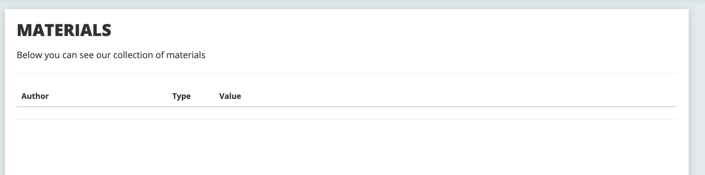

**Contact Form**

The contact form is fairly self-explanatory. Any information written here will be sent to the consortium.

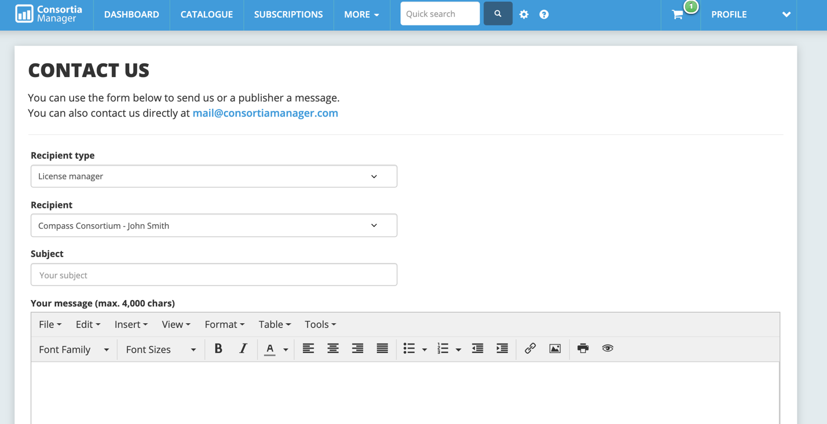

**Contact Book**

The contact book will contain information from other library members of the consortium, the consortium contacts, and publishers/vendors.

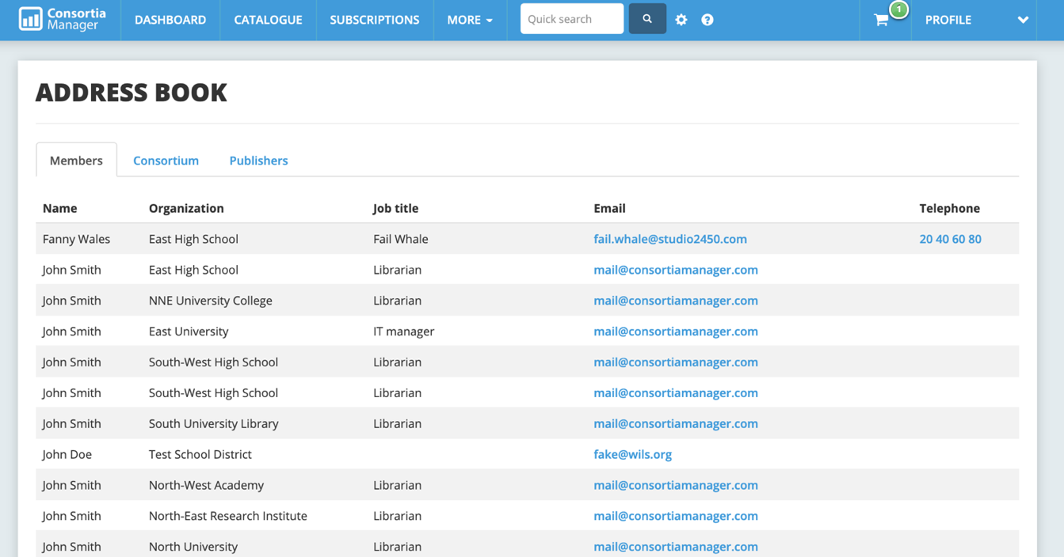

**Reports**

Users can create a variety of reports that can be saved and exported.

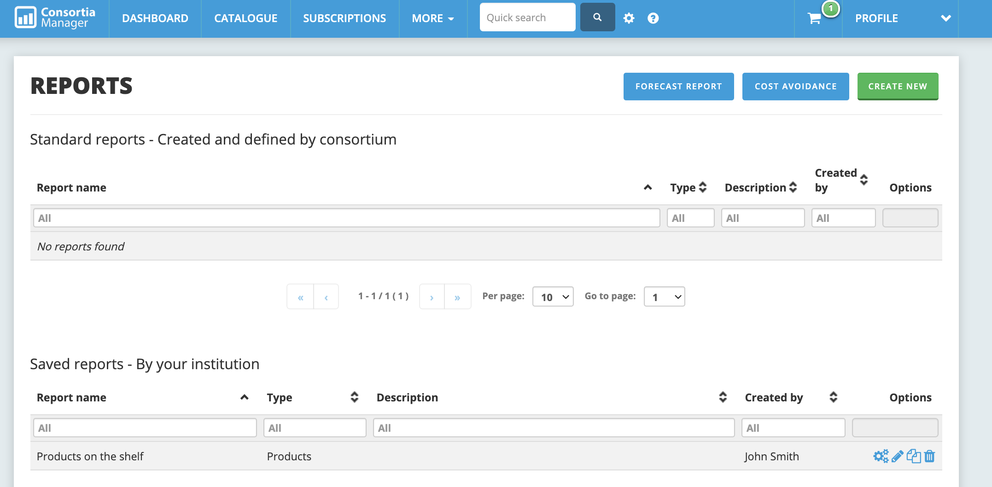

For example, a library might wish to run a monthly report of subscription data and the date they were invoiced by the consortium. There are several options on the left-hand side that will allow the user to limit their search field.

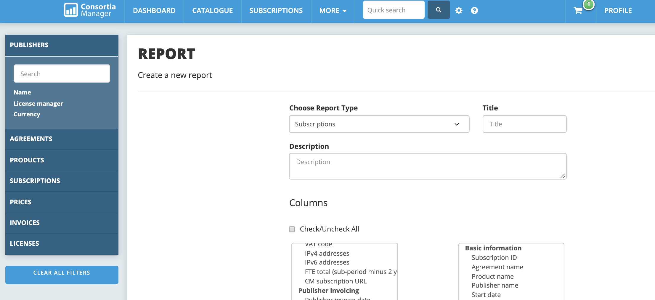

Secondly, they can further select which columns they’d like to see in the Excel report.

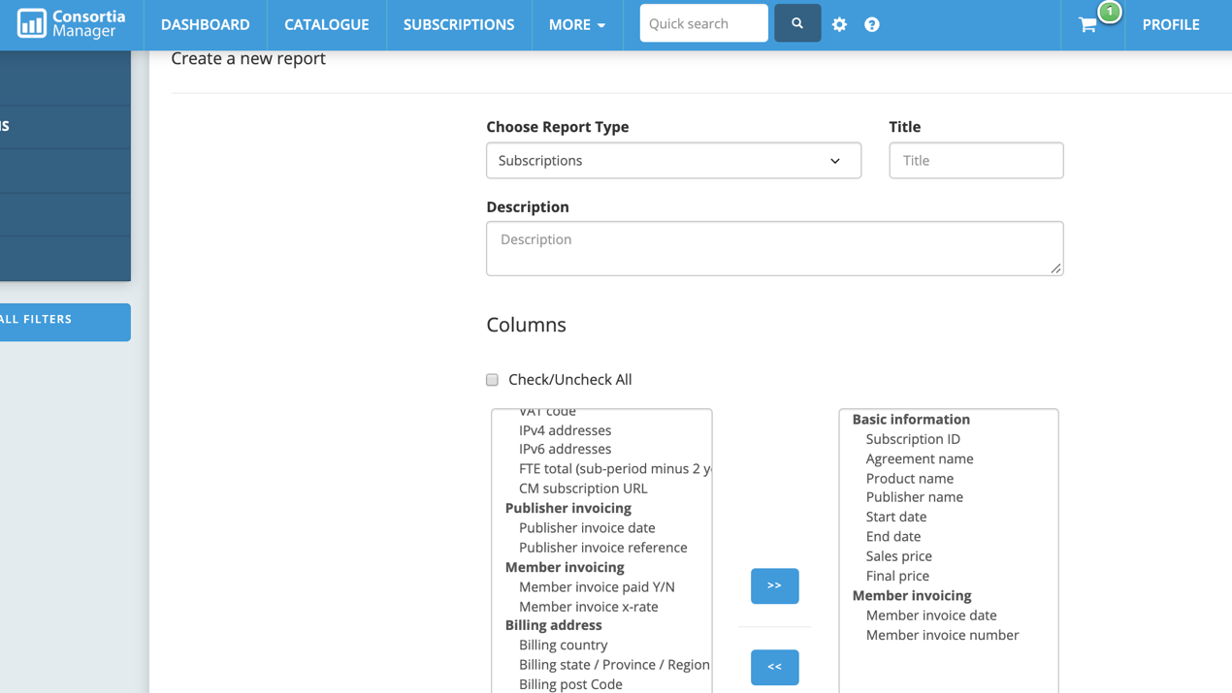

At the bottom of the reports page, users can generate the report to view it now as well as save the report for future use, which is especially helpful if the same information is pulled on a regular basis.

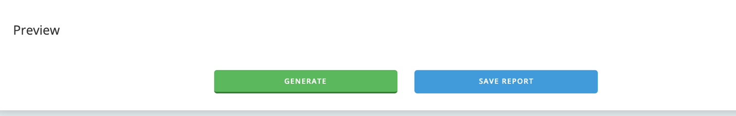

All users and administrators will be able to view and run reports collectively. The consortium can also create and save a report for their member libraries.

**Switch Accounts**

Some libraries may be part of multiple consortia that use CM or users may work at more than one library using CM. Should that be the case, users can choose which consortium or library they want to interact with when logging in, as well as switching accounts when moving from one consortium or library page to another.

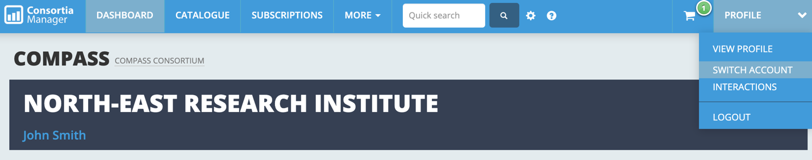

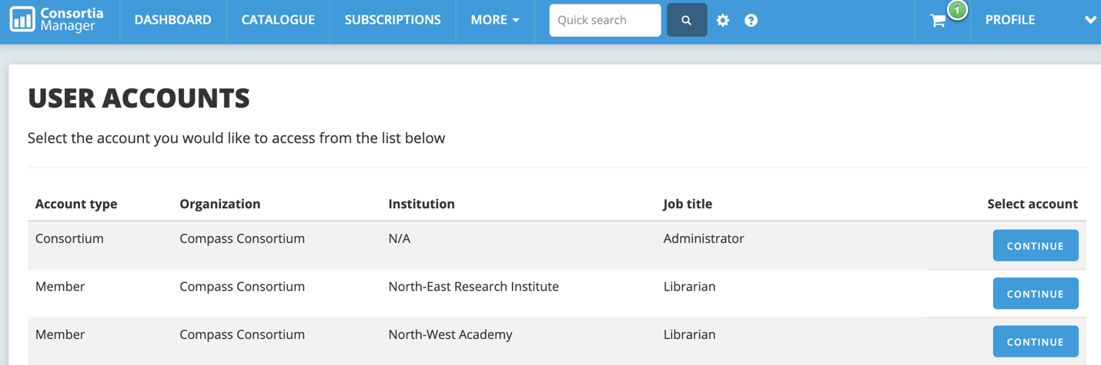

**Interactions**

The interactions page will give the user a comprehensive history of what interactions have occurred with the system. Note these can also be filtered as they pertain to specific issues, such as which user or member completed a task, which actions regarding IP addresses were taken, and actions relating to subscriptions, offers, and products.

