***LOUIS Mutual Aid Principles***

*Resubmitted to the LOUIS Executive Board with modifications on April 5, 2019*

**Background**

The LOUIS consortium and its member institutions recognize their vulnerabilities to natural and manmade disasters. During and after such events, campuses and/or library facilities may be closed for extended periods of time owing to damage or safety concerns. Given the nature of the disasters, people in cities and/or surrounding areas may be evacuated or otherwise displaced, affecting students, faculty, and staff. Collectively, LOUIS and its member institutions are committed to assisting one another to ensure continuity of and access to library services for affected students, faculty, and staff. Assistance may take the form of helping with the recovery or replacement of resources, facilitating access to sources, sharing expertise, and providing non-material support in whatever ways may be feasible. However, it should be noted that there are several organizations that provide aid in disaster recovery for libraries (see Appendix A for a brief list of such organizations). It is not the intent of this document, the consortium, or its membership to duplicate the efforts of such groups.

**What LOUIS Will Do**

For assistance in disaster preparedness, LOUIS could be asked to:

* Maintain a web-accessible inventory of contact information for key positions/individuals at member institutions whom institutions can contact for assistance. This inventory should be reviewed annually to ensure it is up-to-date.
* Maintain a web-accessible inventory of preservation/conservation experts, conservation lab facilities, and other equipment within the membership that may be available to assist in recovery efforts. The inventory should be reviewed annually to ensure it is up-to-date.
* Provide access to ongoing professional development activities to ensure that members can share information about their experiences and disaster recovery practices and remain up-to-date on current disaster recovery practices, processes, and products.

**What the LOUIS Membership Will Do**

Rendering assistance will always be voluntary and in compliance with all applicable policies and procedures at parent institutions and the Board of Regents. Member institutions should bear in mind the impact that policies from the Office of Risk Management and obligations to state contracts may have on their ability to render assistance. These principles are subject to periodic review and revision as needed by the LOUIS Executive Board and consortium membership. It has been recommended that assistance be “triaged” regionally – that is, libraries that are affected should look to their closest unaffected peers for assistance. LOUIS institutions will strive to assist other members impacted by disasters through the following actions:

* Extending outstanding interlibrary loans to affected institution(s) and waiving late and replacement fees as appropriate (especially as replacement monies may emerge from insurance claims).

Providing affected faculty and students access to library facilities and resources and extending borrowing privileges, where practicable, including LALINC borrowing privileges.

* Permitting displaced faculty and students to use chat reference (where available) and other library-related remote help systems.
* Understanding institutional policies for extending affiliate status to temporarily displaced faculty/staff who may relocate to an institution’s area. Such understanding can expedite the temporary provision of access to library content, services, and facilities as is appropriate.
* Providing workspace and/or network access for displaced library personnel during extended closures.
* Providing/securing donations of materials to rebuild collections as appropriate/available;
* Sharing conservation and preservation resources as feasible, including equipment and personnel expertise.
* Supporting lines of communication about needs and possible assistance, including facilitating or making calls for affected staff.
* Promoting relief efforts for residents of affected areas (e.g., publicizing groups collecting donations of money, food, water, or other material goods).
* *What else might we add to this list? Catherine Dean has raised the question of printing services, but I’m not sure that could be universally compelled. ULM’s printing services are paid for by student fees, and only enrolled students can print in the lab (access which is predicated on enrollment data/LDAP authentication).*

A form like the one represented across Figures 1 and 2 (two pages from within a larger document) could be completed by the Dean/Director of member institutions and kept by LOUIS for the contact inventory listed under **What LOUIS Will Do*.*** It is worth noting that the Hackensack Memorandum of Understanding (MOU) also had a third page that contains places for authorized *institutional* authorities to sign acknowledging the agreement. This may well should be a consideration for the consortium and its member institutions. It should also be noted that the MOU involves cost tracking and recovery that very likely fall outside of the purview/authority of the consortium and its members and beyond the scope of the intention of this mutual aid document. However, Figure 1 and the authorized signatures fields from Figure 2 would be a very good template for amassing contact information and detailing assistance that an institution is willing and able to provide.

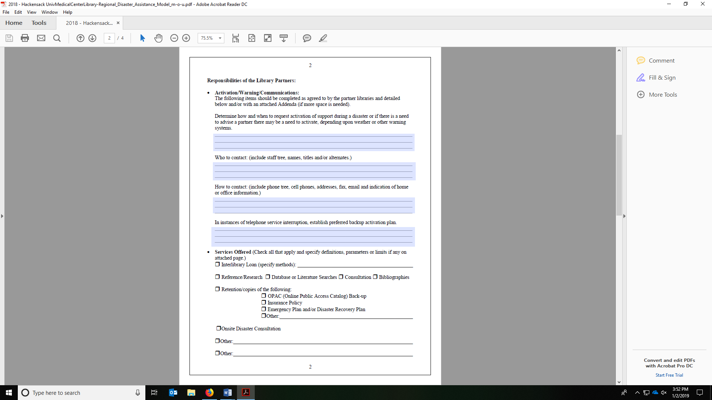

**Figure 1.** Taken from the Hackensack Memorandum of Understanding (MOU).

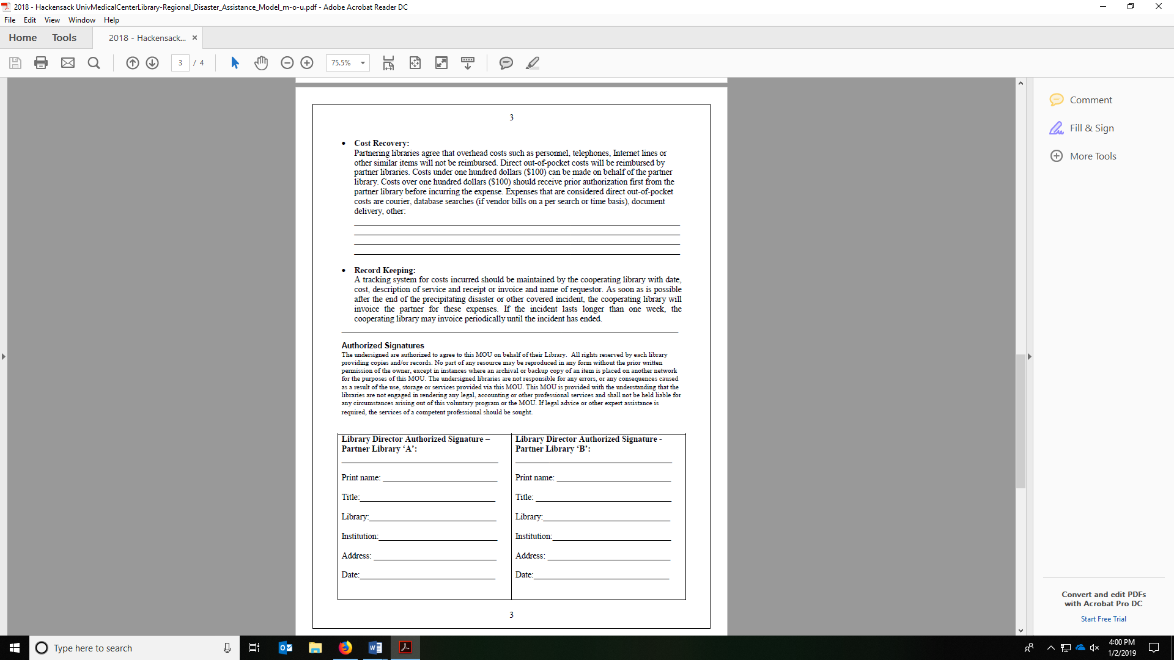

**Figure 2.** Taken from the Hackensack MOU.

**Appendix A: A Brief List of Disaster Aid Organizations and Resources for Libraries**

* Alliance for Response (AFR): <http://www.heritageemergency.org/initiatives/alliance-for-response/afr-home/>
* **American Institute for Conservation of Historic and Artistic Works (AIC):** <https://www.culturalheritage.org/resources/emergencies/national-heritage-responders#.Vh_iIOkY594>
* American Library Association (ALA) Disaster Relief Fund: <http://www.ala.org/advocacy/natural-disasters>
* Heritage Emergency National Task Force (HENTF): <https://culturalrescue.si.edu/hentf/>
* Louisiana Library Association (LLA) Disaster Relief Fund: <https://llaonline.org/LLA/Disaster_Relief/LLA/Disaster_Relief_Contributions.aspx?hkey=42435b53-c7df-4856-9f01-145f4a4cb9ba>
* LYRASIS’ Disaster Assistance Service: <https://www.lyrasis.org/services/Pages/Digital-and-Preservation-Services.aspx>
* Northeast Document Conservation Center (NEDCC): <https://www.nedcc.org/free-resources/disaster-assistance/emergency-phone-assistance>
* Smithsonian Cultural Rescue Initiative: <https://culturalrescue.si.edu/>

The ALA also maintains a website of disaster recovery resources: <https://libguides.ala.org/disaster/response>

The Institute of Museum and Library Services (IMLS) lists several resources include grants available to affected libraries: <https://www.imls.gov/blog/2017/09/natural-disaster-recovery-resources-museums-and-libraries>